New York CEEDAR State Leadership Team
Inclusive Practices Guidance Document

Background

The Collaboration for Effective Educator Development, Accountability, and Reform (CEEDAR) Center supports states to create aligned professional learning systems that provide teachers and leaders resources for delivering and supporting effective instruction for all students with disabilities in inclusive settings. The New York CEEDAR State Leadership Team is a collaboration between the New York State Education Department (NYSED), several local education agencies (LEAs), and five leading New York Institutions of Higher Education (IHEs):

- CUNY Queens College
- New York City Department of Education
- Niskayuna Central Schools
- SUNY Buffalo State
- SUNY New Paltz
- Syracuse University
- Touro Graduate School of Education

Vision Statement

The New York CEEDAR State Leadership Team (NYSLT) believes that each student in New York State deserves the opportunity to be educated in inclusive settings to the maximum extent appropriate and consistent with their individual needs. To that end, each teacher and leader in New York State must be equipped with the skills and evidenced-based practices to lead inclusive classrooms and schools. NYSLT developed the following vision statement for educator preparation reform to guide their efforts.

Vision Statement for Educator Preparation Reform:

Through collaborations among NYSED, LEAs and IHEs, every New York State education professional will be prepared with the knowledge, skills, and dispositions to meet the academic, social, emotional, and behavioral needs of all students, including students with disabilities and learning differences, in inclusive settings. Employing high-leverage and culturally responsive and sustaining practices, every New York State educator and leader candidate will be prepared with the knowledge, skills and dispositions to make a positive impact in classrooms, schools, and districts.

Theory of Action

NYSLT believes that when educator preparation experiences in the state of New York are grounded in a common understanding of inclusive instructional practices, then teachers and leaders will be better equipped to flexibly use these practices in concert with evidence-based practices to meet the needs of all learners in inclusive settings. In spring 2019, NYSLT members developed a technical assistance blueprint with goals related to educator preparation reform and supporting policies. Goal 1 of the blueprint states that the team will identify a set of practices that can be used across the preservice to inservice preparation continuum for general educators, special educators, and leaders to promote and support inclusive settings. The following graphic shows NYSLT’s theory of action for their educator preparation reform goal.

Figure 1. Theory of Action for Educator Preparation Reform

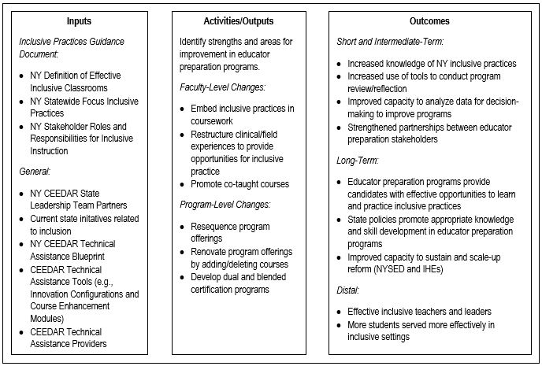

Inputs

This section outlines NSLT’s guidance for inclusive practices specified in the logic model, including a definition of effective inclusive classrooms, a description of the inclusive instructional practices selected for statewide focus, and the roles and responsibilities of various stakeholder groups in promoting these practices.

New York Definition of Effective Inclusive Classrooms

Effective inclusive classrooms in the state of New York are guided by the following principles:

- Equity: High-quality inclusive classrooms and schools ensure that all students have access to a full range of culturally responsive and sustaining academic and social experiences and opportunities.
- Access: Effective inclusive classrooms and schools feature universally-designed, culturally responsive and sustaining instruction delivered within multi-tiered systems of support (MTSS).
- Collaboration: High-quality inclusive classrooms require ongoing collaboration between general education teachers, special education teachers, school leaders, related service providers, IHE leaders and faculty, SEA and LEA leaders, and other key educational stakeholders.
- Evidence-based practices: Teachers and leaders identify and implement evidence-based practices to plan, deliver, and assess specially-designed instruction; collect data to understand student strengths and needs; identify appropriate accommodations and/or modifications; implement positive behavioral support strategies; and increase accessibility to the curriculum.
- Outcomes: Effective inclusive instruction improves students’ academic, behavioral, and interpersonal outcomes.

New York Statewide Focus Inclusive Practices

Five inclusive practices will serve as a statewide focus and common foundation for NYSLT’s educator preparation reform efforts. When implemented with fidelity and consistency, NYSLT believes that these practices will help the team meet the goal of preparing New York educators with the knowledge, skills, and dispositions to promote and support inclusive practices in classrooms, schools, and districts.

NYSLT chose to focus on these five practices after conducting a statewide and national review of resources for inclusive instructional practices. The practices align with the high-leverage practices (HLPs) identified by the Council for Exceptional Children and the CEEDAR Center. Implementation of the five focus HLPs will allow for consistency across the state in improving teachers of inclusive classrooms and leaders that support them. Although there are many other important instructional practices, narrowing the focus to the following five HLPs will provide an initial framework for preparing teachers and leaders for effective inclusive classrooms that is specific to the needs and context of New York schools.

- HLP1: Collaborate with professionals to increase student success
- HLP13: Adapt curriculum tasks and materials for specific learning goals
- HLP12: Systematically design instruction toward a specific learning goal
- HLP7: Establish a consistent, organized, and respectful learning environment
- HLP4: Use multiple sources of information to develop a comprehensive understanding of a student’s strengths and needs

New York Stakeholder Roles and Responsibilities for Inclusive Instruction

Teachers: Create an equitable classroom culture where each student is engaged and receives the educational supports and services necessary to access rigorous instruction.

Actions:
- Promote individualization by adapting and adjusting inclusive practices to meet individual students’ academic, social, and emotional needs.
- Ensure equitable access for all students with a focus on the intersection of equity and inclusion.
- Differentiate instruction for all learners by establishing specific learning goals, developing clear learning progressions, and selecting appropriate instructional strategies, activities, and experiences.
- Work with students, parents, educators, related service providers, and school leaders to collaboratively develop individualized education programs that feature instructional and behavioral supports, accommodations, and modifications that lead to student growth.
- Advocate for students and foster parental advocacy and student self-advocacy.

School Leaders: Promote a vision and structure supportive of a schoolwide inclusive culture.

Actions:
- Promote shared accountability for each student (IC-2.0, PSEL 1).
- Create structures that support inclusive classrooms (IC 2.0, PSEL 9).
- Provide instructional leadership for all students (IC-1.0, PSEL 4).
- Engage parents to foster student learning for each student (IC-3.0, PSEL 8).
- Support teachers to use effective inclusive practices for instruction, behavior, assessment, and collaboration.
- Advocate for best practices for inclusion at the school level.

Parents: Provide support and advocacy for their child’s education.

Actions:
- Advocate for equitable and accessible education for their child.
- Developing meaningful partnerships with teachers, leaders, and schools.

Students: Communicate, participate, and advocate for the supports and services needed for their own success.

Actions:
- Self-advocate for supports and services he/she needs.
- Communicate with peers, teachers, and other professionals effectively.
- Actively develop and participate in their own IEP and transition plan.
- Participate as an engaged learner.

Activities/Outputs

NYSLT partners have committed to making tangible reforms to educator preparation programs and policies so that every New York State education professional is prepared with the knowledge, skills, and dispositions to effectively serve students in inclusive settings. Building on efforts already underway at their institutions, New York partner IHEs will internally review and reflect on their educator preparation program offerings in order to identify strengths, gaps, and duplications in their teacher and leader preparation programs, with a particular focus on high-leverage inclusive practices as defined in this guidance document. Based on this information, each partner IHE will determine action steps specific to their institutions, which will be captured in the state technical assistance blueprint. Below is a list of actions that IHEs might take to strengthen a focus on inclusive practices within their general education, special education, and leadership preparation programs:

- Embed inclusive practices into special education, general education, or education leadership coursework content, activities, assignments, and assessments.
- Restructure clinical and field experiences to provide teachers and leaders opportunities for inclusive practice.
- Provide opportunities for co-taught coursework across departments in educator preparation programs.
- Resequence coursework and field experiences to use existing program “real estate” more effectively.
- Renovate existing programs through changes in course offerings, redistributing credit hours, adding/deleting course offerings, etc.
- Develop blended or dual certification programs.

Outcomes

Short-and intermediate-term outcomes of the work include:
- Increased knowledge of the inclusive practices identified by NYSLT as critical to the success of inclusive education in New York state.
- Increased use of research and evidence-based tools to conduct program reflection and review processes.
- Improved capacity to analyze data for decision-making to improve preparation programs.
- Strengthened partnerships between educator preparation stakeholders.

As a result of these activities, NYSLT partners will achieve the following long-term outcomes:
- Educator preparation programs provide candidates with effective opportunities to learn and practice inclusive practices.
- State policies, including policies related to licensure, certification, and preparation program approval/evaluation, will promote appropriate knowledge and skill development within educator preparation programs.
- Partners including NYSED, local education agencies, and IHEs will improve their capacity to sustain and scale-up reform.

These activities will ensure that teacher and leader candidates are prepared with the knowledge, skills, and dispositions to serve students with disabilities in inclusive settings, with the ultimate goal of ensuring that more students are being served more effectively in inclusive settings.

