Culturally Responsive Education
in the Content Areas

Overview and Speaker Notes

Intended Audience: Teachers in grades K-12 representing all content areas, including special education.

Overview for Facilitators:
The CEEDAR Center is pleased to provide the anchor presentation: Culturally Responsive Education in the Content Areas. The materials are designed to be included in a pre-service teacher preparation course or in-service teacher professional development program. This resource will increase in-service professionals’ ability to improve students’ readiness for college and careers.

Speaker Notes
The speaker notes are what the facilitator can say, verbatim, to explain each slide and the activities. Speaker notes are provided for most of the PowerPoint slides included. The notes provide additional details about the information presented in a particular slide, including the context for the information being presented as well as further elaboration of key points being discussed. The notes are provided as a guide, and speakers should feel free to modify these as needed.
- Text formatted in standard font is a sample script for the presenter. While these may be read verbatim, speaker notes are intended as a guide for the presenter and may be modified as needed.
- Text formatted in italics is intended as directions or notes for the facilitator; italicized text is not meant to be read aloud.

Materials Required
- Computers or tablets with internet access for participants (if possible)
- Handouts
- Projector with audio capable of playing video
- Large pieces of paper (for group use) and markers
- Presentation slides with speaker notes

Objectives: After participating in this professional learning opportunity, participants will be able to:
- Define High Leverage Practices (HLPs) that are particularly supportive of students with disabilities and determine the rationale for integrating them into preparation programs.
- Define CRE principles and discuss how they can be integrated with HLPs to strengthen educator preparation coursework.

Outline of Session Activities and Approximate Time
Topic | Slides | Activity | Time
Introduction and Objectives | 1-3 |  | 2 minutes
Culturally Relevant Teaching Practices | 4-6 |  | 3 minutes
State Policy and Practice Portrait | 7 |  | 5 minutes
Teacher Preparation and Professional Development | 8 |  | 2 minutes
K-12 Learning Experience Reflection | 9 | Self-awareness activity (handout) | 15 minutes
High-Leverage Practices | 10-14 |  | 10 minutes
High-Leverage Practices and Culturally Relevant Education | 15-22 | CRE and HLPS activity (handout) | 20 minutes
Instructional Practices in Culturally Relevant Education | 23-27 |  | 8 minutes
Best Practices and Instructional Strategies | 28-34 | ELA Lesson Analysis (handout) | 20 minutes
Culturally Responsive Education in English Language Arts | 35-40 | Culturally Responsive Texts for Students (handout) | 20 minutes
Culturally Responsive Education in Math | 41-50 | Reflecting on Math Instruction (handout) | 27 minutes
Tools and Resources | 51-54 |  | 5 minutes

Speaker Notes with Slides

Slide 1 | 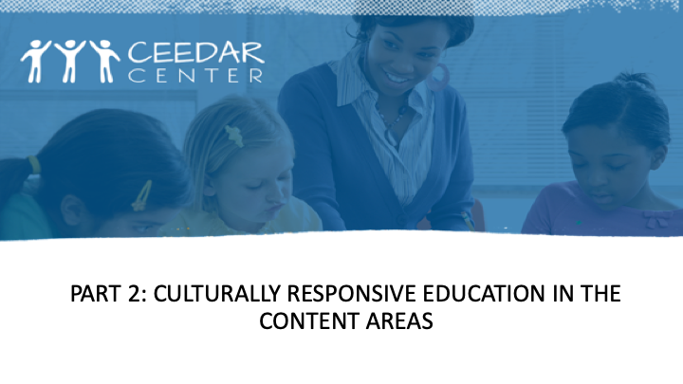
Slide 2 | 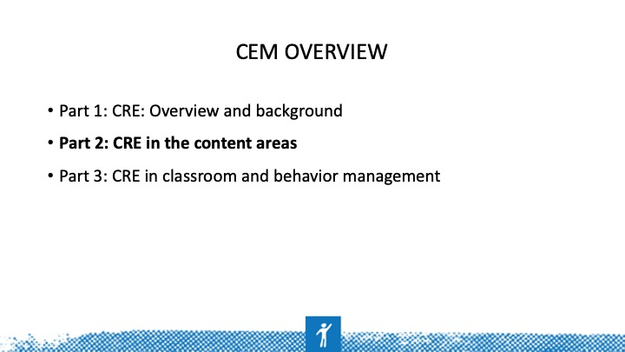 | This CEM is organized in three parts: overview and background, CRE in content, and culturally relevant classroom management. Some overlap exists between the overview and background and the other two parts.
Slide 3 | 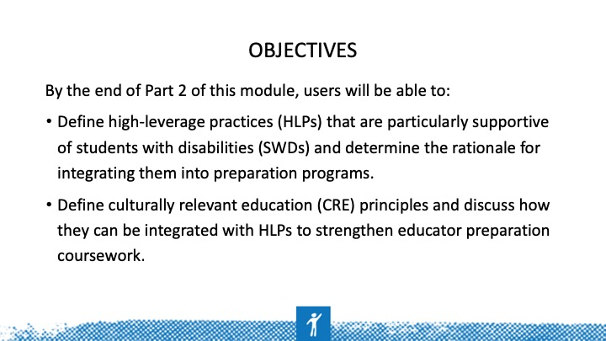
Slide 4 | 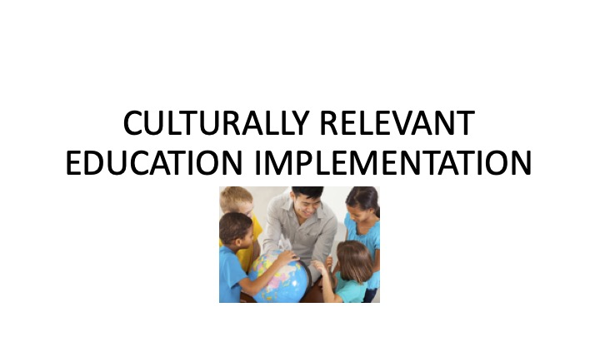
Slide 5 | 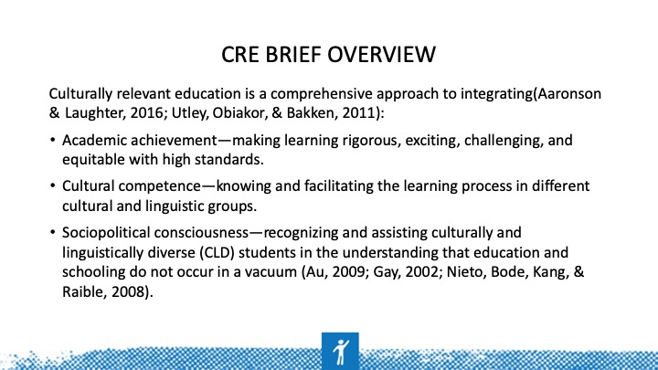 | CRE values students’ cultural and linguistic resources and views these as assets to build upon rather than deficits to be overcome through schooling.  CRE measures student development in multiple ways, in addition to standardized test scores.  CRE highlights the importance of strong and warm working relationships among school participants and serves as cultural organizer, mediator, and orchestrator of social contexts. CRE helps students and families bridge borders between home and school cultures (Orosco & Abdulrahim, 2017).  Utley, C. A., Obiakor, F. E., & Bakken, J. P. (2011). Culturally responsive practices for culturally and linguistically diverse (CLD) students with learning disabilities. Learning Disabilities: A Contemporary Journal, 9(1), 5-18.
Slide 6 | 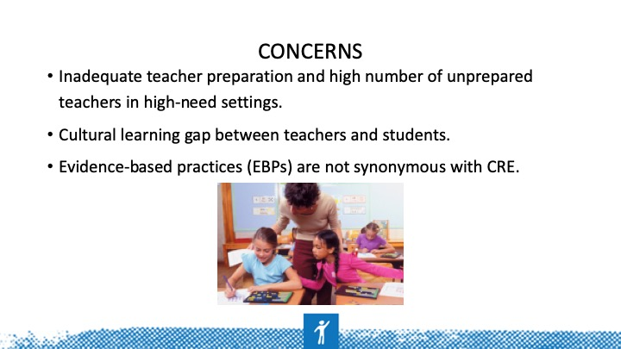 | Many teachers are inadequately prepared (e.g., with relevant content knowledge, experience, and training) to address CLD students’ leaning needs.  Inadequate preparation creates a cultural learning gap between teachers and students and can limit educators’ abilities to choose  effective evidence-based practices (EBPs).  EBPs are not synonymous with CRE.
Slide 7 | 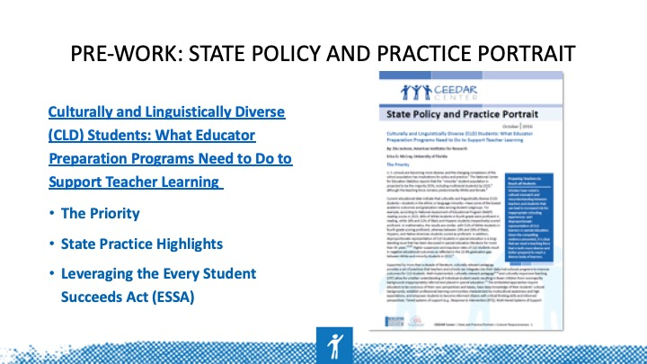 | Before beginning the module, have participants read this portrait and reflect on the role of teacher education programs in developing educators prepared to teach diverse learners. In this article, authors highlight the racial and cultural gap between teachers and the student population and the need for culturally relevant learner-ready teachers, also supported by NTEP/CCSSO’s learner-ready teacher guidance document. These documents highlight a national concern about how we effectively educate students who are CLD. Reflect on how your educator preparation program is preparing educators to effectively teacher CLD students.
Slide 8 | 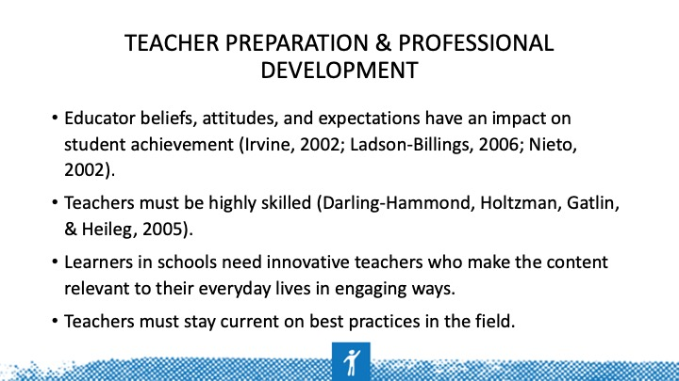
Slide 9 | 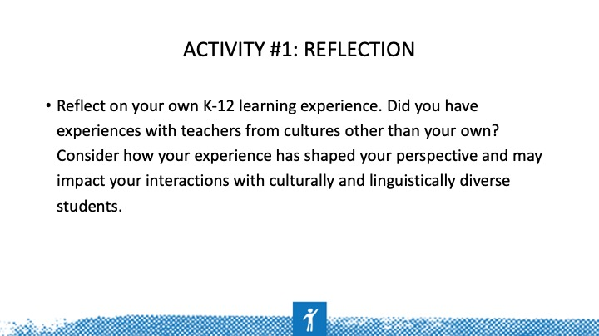 | Self-awareness activity. The objective of this reflection is to allow students to be aware of their own learning experience and how it has shaped their perspectives. Most teachers teach the way teachers taught them. Being aware of the worldview we bring to the classroom and considering how it may hinder our ability to connect with and learn from students is important.
Slide 10 | 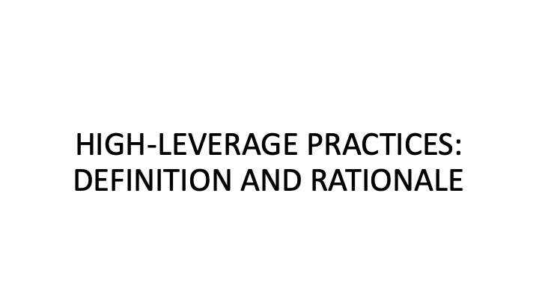
Slide 11 | 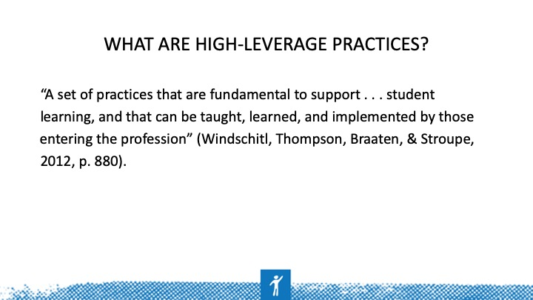 | (McLeskey & Brownell, 2015)  HLPs are HOW teachers deliver instruction. All teachers should have deep knowledge in a core set of effective instructional practices.  An HLP is an action or task central to teaching. If carried out skillfully, HLPs increase the likelihood that teaching will be effective for students’ learning. They are useful across a broad range of subject areas, grade levels, and teaching contexts and are helpful in using and managing differences among students. The set of HLPs is intended as a common framework for teaching that will provide a core curriculum for an educator preparation program.
Slide 12 | 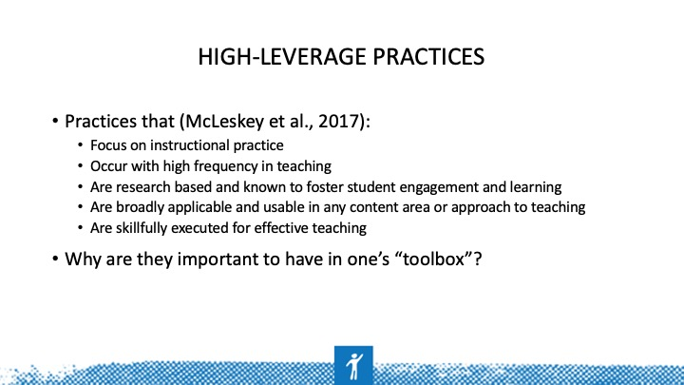 | HLPs are not constrained by content or grade level like EBPs are. HLPs are cross-cutting practices that all teachers use in delivering EBPs. HLPs are about how teachers deliver instruction  (McLeskey et al., 2017).  Both research and professional wisdom note the importance of practice — not just any type of practice, but those aspects of practice that are critical to success. Additionally, research supports that practices combined with feedback and emphasis on the critical components of a practice ARE most important in ensuring teachers gaining mastery and expertise over time (McCleskey & Brownell, 2015).
Slide 13 | 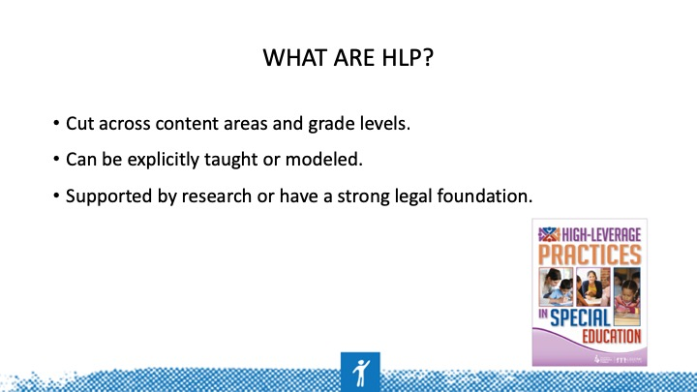 | Practice combined with feedback focused on main components of effective performance (HLPs) is essential to developing expertise over time. In other practice-based fields, experts are defined by having a core set of knowledge and skills that they flexibly use and integrate depending on the context.  “In experts, conceptual knowledge and skills along with situational knowledge (or understanding of when to apply particular knowledge and skills) are well integrated, organized,  and easily accessible (Bransford Brown, & Cocking, 1999). Experts have “the knowledge and skills readily available from memory that are needed to make sense of future problems and opportunities” (Brown, Roediger, & McDaniel, 2014, p. 2), and such well-integrated knowledge is acquired through practicing in increasingly complex settings over time.”  After HLPs are identified, they can be modeled and practiced across different content areas using content-specific strategies (e.g., using explicit instruction in reading to teach a summarization strategy).  Teacher educators can demonstrate how the practice changes depending on the structure of the content being taught (McCleskey & Brownell, 2015).
Slide 14 | 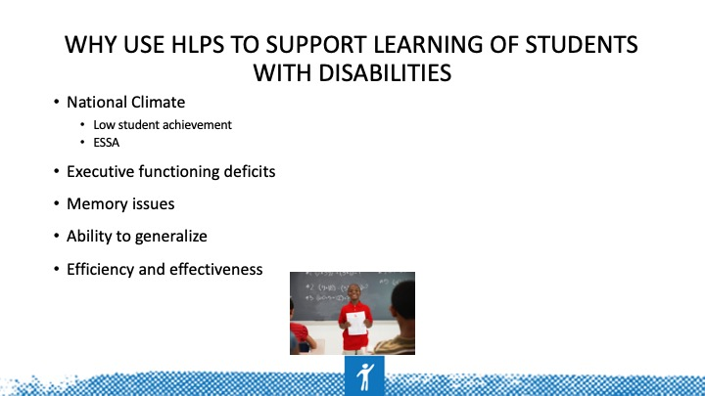 | NAEP scores consistently show the gap in achievement between SWDs and non-disabled peers. ESSA calls for states to provide an equitable education for ALL students where SWDs and other students from underrepresented groups are able to achieve at high levels. Many SWDs struggle with memory, planning, and self-regulation skills. HLPs address these and other executive functioning skills that permeate all aspects of learning.  Finally, HLPs allow teachers to efficiently and effectively ensure that students acquire new knowledge and skills with little need for remediation.  An ethical imperative exists to provide all children with equitable education. Subgroups of students are not performing well in school, and their outcomes are of great concern.  If we want all students to have more equitable outcomes, we must ensure that ALL teachers are well equipped to teach ALL students.
Slide 15 | 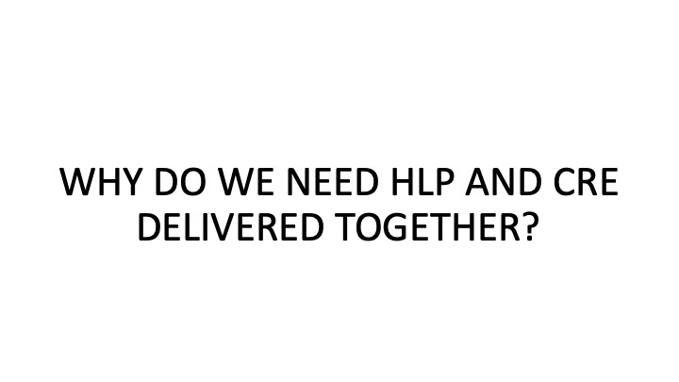
Slide 16 | 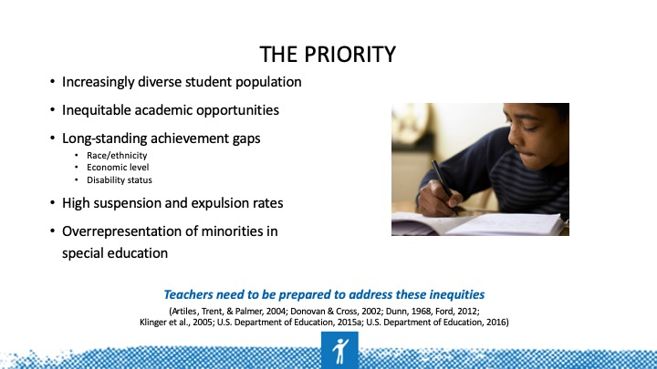 | These issues are not new; we have more two decades of research on the achievement and access gap for students in poverty and SWDs.  Growing “minority” population: 55% by 2025 (U.S. Department of Education, 2015)  Donna Ford (2015) writes about the opportunity for African American boys to have access to gifted education and honors classes  National Assessment of Educational Progress (NAEP) reading and mathematics scores in 2015  NAEP reading scores in 2015, 46% of White students in fourth grade were proficient in reading while 18% and 21% of Black and Hispanic students (respectively) scored proficient.  In mathematics, the results are similar, with 51% of White students in fourth grade scoring proficient whereas between 19% and 26% of Black, Hispanic, and Native American students scored as proficient. In addition, disproportionate representation of CLD students in special education is a long-standing issue that has been discussed in special education literature for more than 45 years. Higher suspension and expulsion rates of CLD students result in negative educational outcomes as reflected in the 13.4% graduation gap between White and minority students in 2013.
Slide 17 | 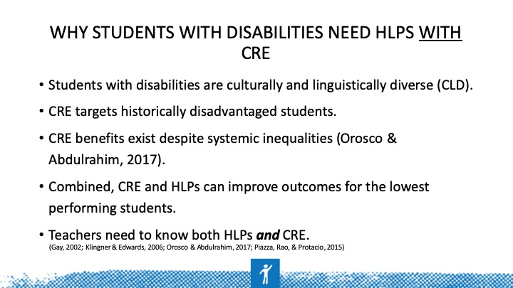 | CRE can help teachers and schools overcome the historic underachievement and underappreciation of CLD students and SWDs. Although larger structural forces substantially inhibit student achievement, CRE is one way teachers and schools can better support CLD SWDs despite current limitations of the sociopolitical, educational, and economic systems.  Orosco and Abdulrahim’s study (2017) examines culturally responsive pedagogy across the fields of special education, multicultural literacy education, and teaching English language learners (ELLs). A systematic review of recommendations identified culturally responsive practices (CRPs) in five key areas: dialogue, collaboration, visual representation, explicit instruction, and inquiry.
Slide 18 | 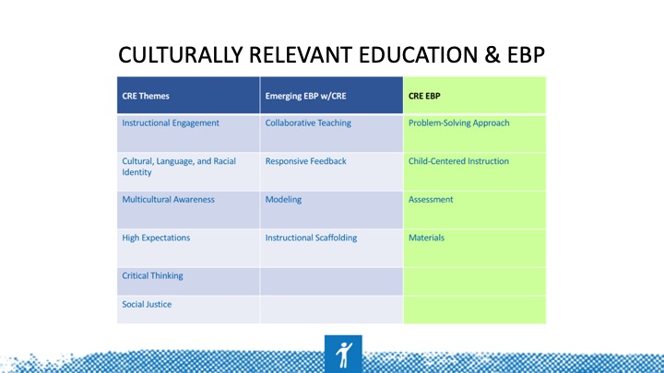 | In the CEEDAR Culturally Responsive Teaching (CRT) IC, authors Aceves and Orosco (2014) found six general CRE themes (i.e., instructional engagement; culture, language, and racial identity; multicultural awareness; high expectations; critical thinking; and social justice); four CRE practices (i.e., collaborative teaching, responsive feedback, modeling, and instructional scaffolding) that were considered emerging EBPs; two recommended teaching approaches (i.e., problem solving and child-centered instruction); and two instructional considerations (i.e., assessment and materials). The CRE literature supports our findings (see Table 1).  (Aceves & Orosco, 2014, pg. 9)  The review was restricted to empirical studies that included at least 50% of CLD students. Authors reviewed studies that examined instructional practices with K-12 student outcomes.  Using ESSA/CEEDAR evidence standards, authors categorized practices found in the literature.  4 levels of evidence  Strong  Moderate  Limited  Emerging  http://ceedar.education.ufl.edu/wp-content/uploads/2014/08/Evidence-Based-Practices-guide.pdf
Slide 19 | 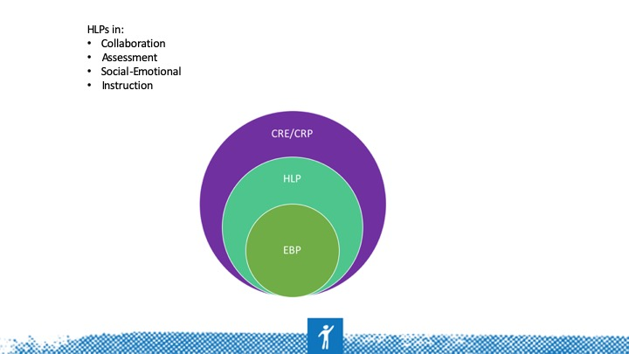 | Although CRE shows promise for enhancing academic outcomes, CRE alone is not enough. CRE is not the same as EBP but, instead, should be delivered in tandem (describe graphic).  CRE and CRPs are not practices that are done in isolation or separately from HLPs or EBPs, but they should envelop EBPs and be delivered seamlessly. Many expert teachers do this automatically, but these skills can be taught and reinforced.
Slide 20 | 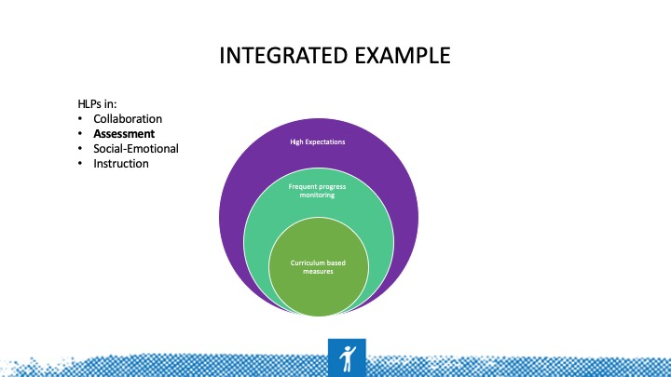 | CRE and CRP are not practices that are done in isolation or separately from HLPs or EBPs, but they should envelop concepts from both practices.
Slide 21 | 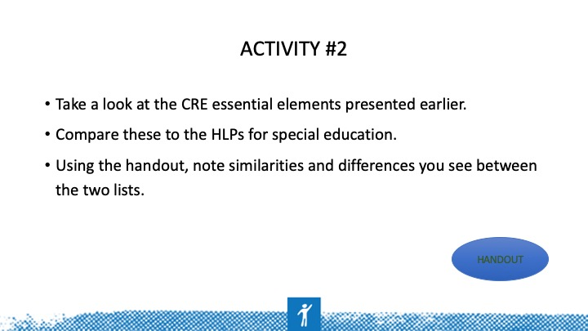 | Take a look at the CRE essential elements presented earlier.  Compare these to the HLPs for special education.  Using the handout, note similarities and differences you see between the two lists.  Refer to Activity 2 on the handout to complete this activity.
Slide 22 | 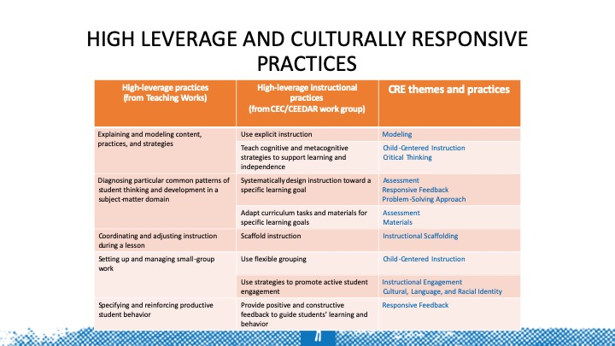 | Provide this as an “answer key” to Activity 2. Looking across the rows, discuss the overlap in these practices.
Slide 23 | 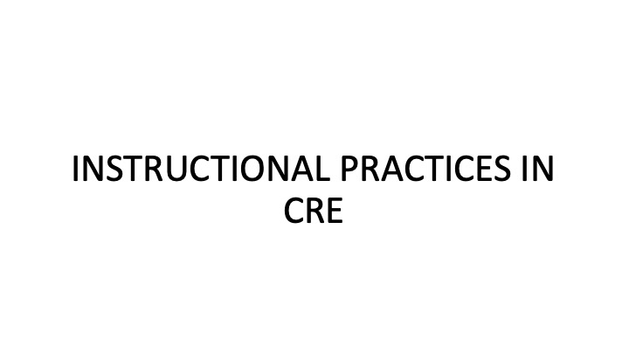
Slide 24 | 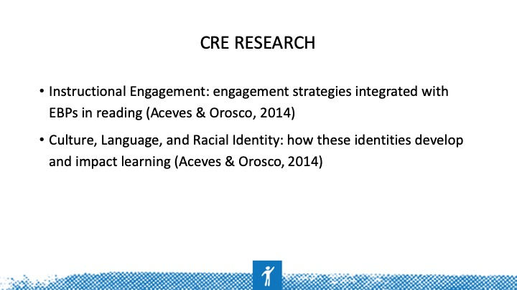 | CRE provides teaching that draws from CLD students’ relevant schemas, background knowledge, and home languages; it also allows students to practice what they are taught (e.g., August & Hakuta, 1997; August & Shanahan, 2006). For example, various classroom studies have indicated that students make greater improvement in reading comprehension when teachers intertwine instructional engagement approaches with skills-based practices (i.e., connections between students’ cultural and linguistic knowledge and lessons) that assist CLD students with integrating new learning information (e.g., Orosco, Swanson, O’Connor, & Lussier, 2013).  Culture and linguistic experiences can help shape students’ identities. Learning may be difficult for many CLD students because they encounter formal schooling as separate from their cultural, linguistic, and racial experiences (Au, 2005; Gipe, 2006). Culturally responsive methods provide teachers with the critical understanding of how students’ cultural, linguistic, and racial identities develop and how these constructs impact learning.  Teachers can make connections by making reading relevant to students’ lives through the choice of topics or materials used or themes in the text.
Slide 25 | 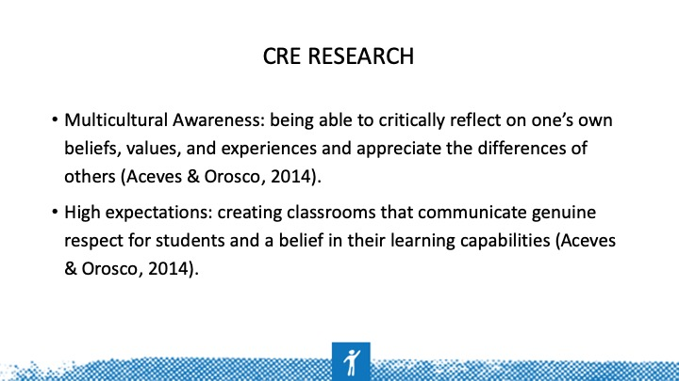 | The ability to objectively examine one’s own cultural values, beliefs, and perceptions provides teachers with a greater understanding, sensitivity, and appreciation of the history, values, experiences, and lifestyles of other cultures, which is particularly important when teachers’ cultures differ from that of their students. It provides teachers with the skills to gain greater self-awareness, greater awareness of others, and better interpersonal skills; it also helps teachers to more effectively challenge stereotypes and prejudices (Banks, 2004).  High expectations refer to the ability to communicate clear and specific expectations to students about what they are expected to know and be able to do (Cahnmann, 2005; Cahnmann & Remillard, 2002; Mitchell, 1998). CRE includes creating classrooms that promote genuine respect for students and a belief in their learning capabilities (e.g., Scheurich, 1998).  For example, Tatum (2006) writes about how he had high expectations for his students and integrated that into literacy instruction: “I introduced James Baldwin's ‘My Dungeon Shook: Letter to My Nephew on the One Hundredth Anniversary of the Emancipation’ giving my students the opportunity to critique society and examine their place within it. We explored such comments as, ‘You were not expected to aspire to excellence; you were expected to make peace with mediocrity’ (p. 7). I asked students to consider the relevance of this essay, not just to young African American men growing up today, but to young men everywhere. Finally, I wanted students to consider the role they played in constructing their own ‘dungeons,’ as well as the roles their teachers, schools, and community played. They might begin to consider why they are in low-level reading tracks or why they are in low-achieving schools.”  Choose content with themes of pursuing excellence, overcoming difficulty, problem solving, and persistence.
Slide 26 | 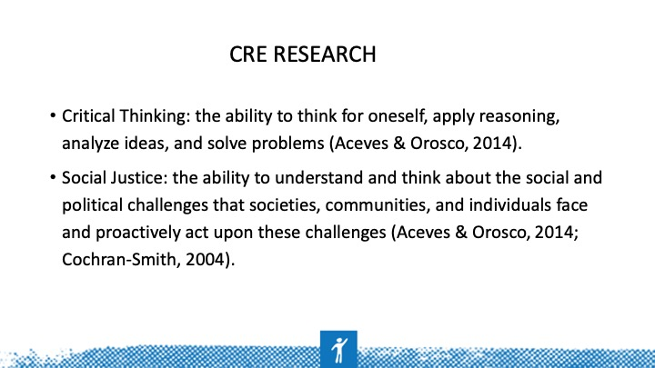 | Critical thinking allows students to share their experiences while applying EBPs. This strategy allows teachers to look past their own points of view and better understand the thoughts of others and in turn help them improve CLD students’ critical thinking skills.  Critical thinking is the ability to think for oneself, apply reasoning and logic to new or unfamiliar ideas, analyze ideas, make inferences, and solve problems (e.g., Diaz-Rico & Weed, 2006). CRE methods provide teachers with the skills to teach students how to become critical thinkers by integrating their cultural and linguistic experiences with challenging learning experiences involving higher order thinking and critical inquiry.  Culturally responsive teachers include a strong social-justice component in their instruction through which they help students identify and confront sociopolitical inequities and issues of social power and class privilege. Teachers with a CRP also nurture a sense of agency and action in their students (Nieto & Bode, 2012); that is, they instill in them a will and sense of efficacy to foster social change.
Slide 27 | 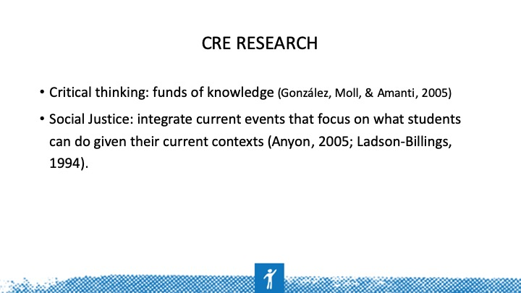 | Funds of knowledge refers to the knowledge base a household has accumulated from the lived experiences and social practices of its members. In the case of working-class households, social practices may include forming of social networks with other households—both kin or otherwise—that may feature the reciprocal exchange of information, labor, or knowledge (Gonzalez, Moll, & Amanti, 2005).  Social justice is the ability to understand and think about the social and political challenges that societies, communities, and individuals face and proactively act upon these challenges (Cochran-Smith, 2004). CRE guides teachers’ practices and curricula because it is centered in students’ cultures, and it provides an active process for students to seek out information about what is happening in the communities around them, which guides them to better understandings of and better solutions for the inequities encountered in their communities (Irvine, 2002).  Consistent with CRE is a pragmatic focus on what students can do given their current contexts, noting that structural change is a long, slow process (Anyon, 2005; Ladson-Billings, 1994).
Slide 28 | 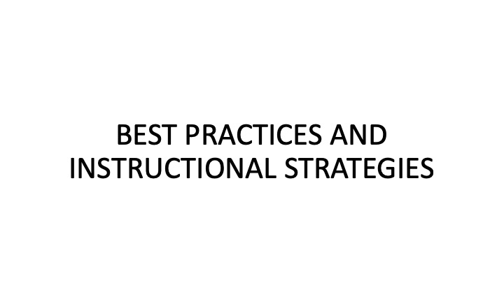
Slide 29 | 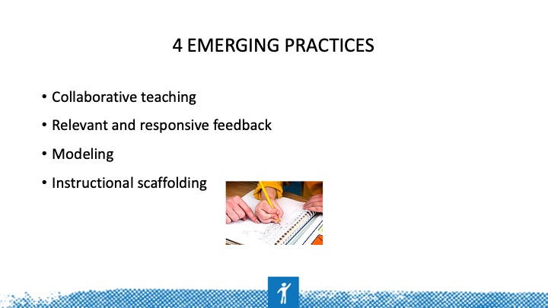 | Research during the past few decades has developed the foundation for EBP that supports teaching for students who struggle with learning basic academic skills. However, despite this research, CLD learners continue to underachieve in United States public schools, which has led researchers and educators to examine research on the development of EBPs with CRE methods. Although empirical research investigating EBPs for diverse students with learning difficulties has increased, a scant research base in this area remains (Aceves & Orosco, 2014).
Slide 30 | 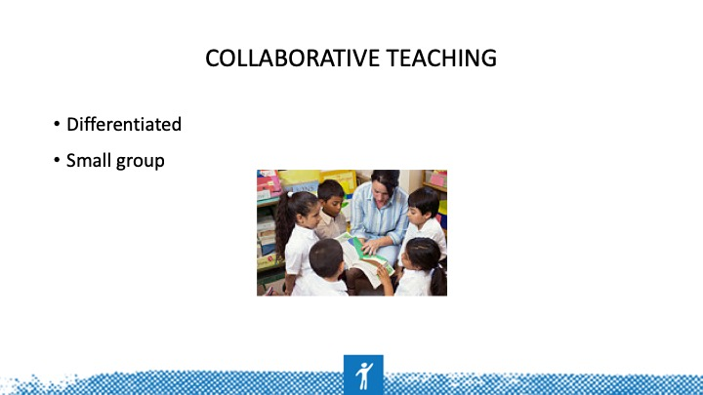 | Collaborative teaching is an umbrella term for instructional methods (e.g., cooperative learning, differentiated instruction, peer teaching, reciprocal teaching) that involve joint intellectual effort (i.e., requiring individual accountability, positive interdependence, and strong interpersonal skills) between students and teachers (Klingner & Vaughn, 1996, 1999; Vadasy & O’Connor, 2011; Vaughn et al., 2011).  Research indicates that practitioners who use direct and explicit collaborative-based approaches to learning to reinforce students’ background knowledge (e.g., interdependence, sharing, collaboration) improve student literacy engagement and motivation (e.g., Au, 2011; Genesee & Riches, 2006).  In collaborative-based instruction, teachers provide a common introduction to lessons and then distribute learning assignments based on students’ academic skills (e.g., reading language level). Although all students learn about the same topic, the assignments may vary according to student ability.  If learning challenges persist, teachers may need to reciprocate and teach specific skills for student understanding. For example, several studies (e.g., Calhoon, Al Otaiba, Greenberg, King, & Avalos, 2006; Klingner & Vaughn, 1996; Sáenz, Fuchs, & Fuchs, 2005) have used collaborative-based learning approaches to engage CLD students in small groups in content-related strategic discussion to assist them in understanding concepts, deriving the main ideas, asking and answering questions, and relating what they are learning to their own cultural backgrounds.
Slide 31 | 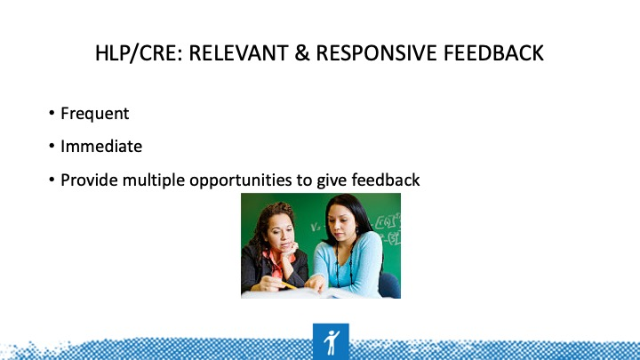 | CR feedback is provided when teachers offer critical, ongoing, and immediate feedback regarding students' responses and participation. Through culturally responsive feedback, teachers supply individualized support regarding performance in a manner sensitive to students’ individual and cultural preferences. This strategy includes incorporating students’ responses, ideas, languages, and experiences into the feedback that is provided (Gersten & Geva, 2003) while inviting students to construct new understandings regarding what they are learning (McIntyre & Hulan, 2013).  Providing responsive feedback is an instructional strategy recommended as a necessary practice in effective instruction with students experiencing academic difficulty (Fuchs & Vaughn, 2012). Responsive feedback has also been implemented as an important strategy within studies involving ELLs (Carlo et al., 2004; Gerber, Jimenez, Leafstedt, Villaruz, Richards, & English 2004; Kamps et al., 2007; Vaughn et al., 2006).  To engage in this critical feedback exchange, teachers must create multiple opportunities for students to respond and fluidly dialogue throughout the day.
Slide 32 | 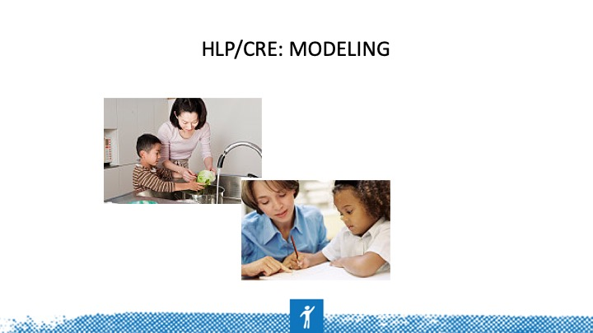 | Teacher modeling has long been viewed as an essential component of effective teaching. As a CR practice, modeling involves explicit discussion of instructional expectations while providing examples based on students’ cultural, linguistic, and lived experiences. Culturally responsive modeling requires teachers to exemplify learning outcomes of CRE, which include strategy use, content learning, metacognitive and critical thinking, and interest and respect for cultural and linguistic diversity.  Research has established the modeling of skills, strategies, and new content as an essential and effective method for teaching English learners (Gerber et al., 2004; Gersten & Geva 2003; Kamps et al., 2007; Vaughn et al., 2006).
Slide 33 | 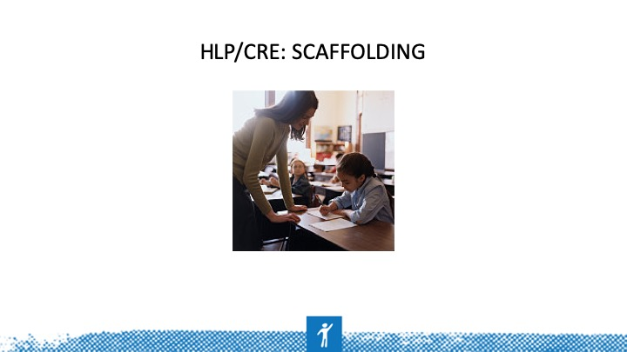 | CR instructional scaffolding occurs when teachers control for task difficulty and promote a deeper level of understanding using students' contributions and their cultural and linguistic backgrounds. Scaffolding skills include using different types of questions (e.g., open-ended questions, analytic questions); providing appropriate wait time and taking turns; extending and acknowledging students’ responses; and using supporting instructional materials (e.g., visual organizers, story maps; Jiménez & Gersten, 1999).  Researchers have integrated scaffolding methods in studies involving students experiencing academic difficulty, including students who speak a second language (Gerber et al., 2004; Goldenberg, 2013; Vaughn et al., 2006). For instance, scaffolding may include reference to ELLs’ primary languages or cultures.
Slide 34 | 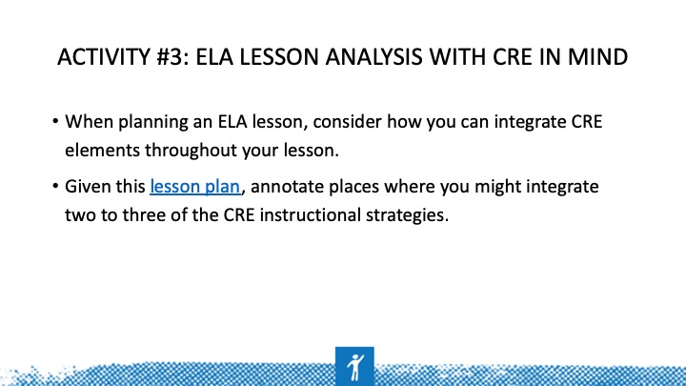 | Use this tool to plan and valuate your math lesson. Participants may use another lesson plan that applies more to their grade level if necessary, the given lesson is for first- through third-grade students. Refer to Activity 3 on the handout.
Slide 35 | 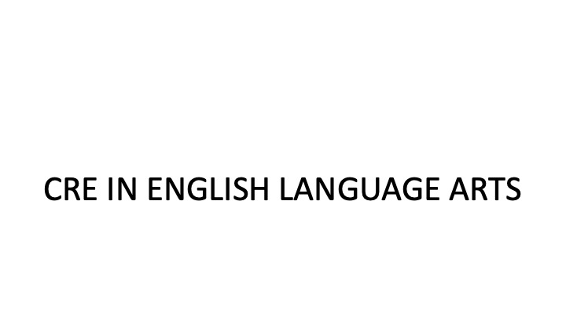
Slide 36 | 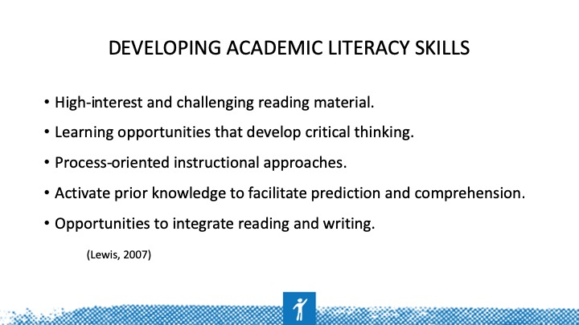 | CR literacy instruction includes a focus on developing academic literacy skills. This can be accomplished by (read slide).
Slide 37 | 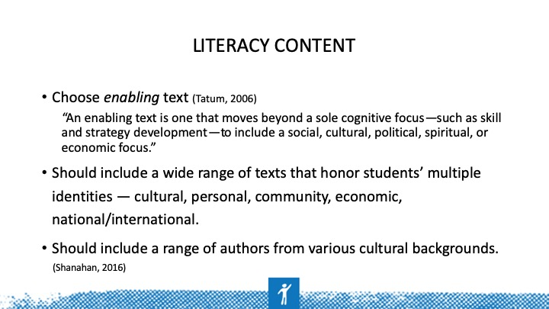 | The literacy development of African American males, both self-generated and school-rendered, connected to larger ideals such as cultural uplift, economic advancement, resistance to oppression, and intellectual development.  During the last 30 years, however, the kinds of texts that African American males as a group encounter in schools have been characteristically “dis-abling.” They lack that broader perspective and largely ignore students' local contexts and their desire as adolescents for self-definition, focusing instead on skill and strategy development.  Utilize a wide range of texts that honor students’ multiple identities — cultural, personal, community, economic, national/international — with the aim to help students define who they are and nurture their academic and personal resiliency inside and outside of schools.  http://www.readingrockets.org/blogs/shanahan-literacy/culturally-responsive-literacy-instruction
Slide 38 | 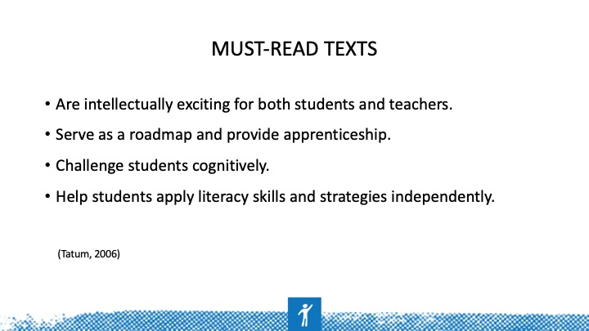 | Must-read texts have four characteristics: They are intellectually exciting for both students and teachers, they serve as a roadmap and provide apprenticeship, they challenge students cognitively, and they help students apply literacy skills and strategies independently.
Slide 39 | 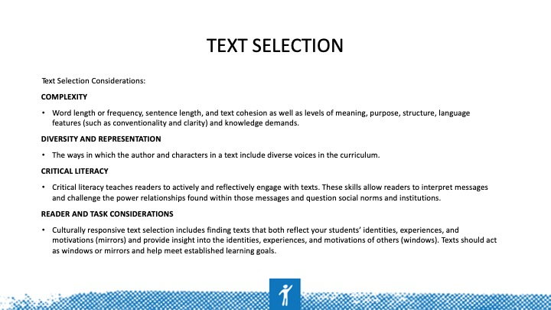 | Finally, educators must decide whether to select the text that is appropriate and culturally responsive and meets the learning objective and state standards. Consider these elements when choosing text.
Slide 40 | 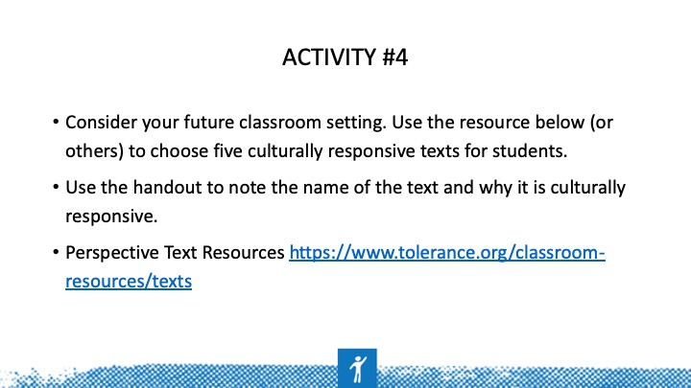 | Use the handout to complete Activity 4. The objective of this activity is for participants to begin to put into action the strategies learned on previous slides for evaluating text and choosing literature that incorporates CRE themes.
Slide 41 | 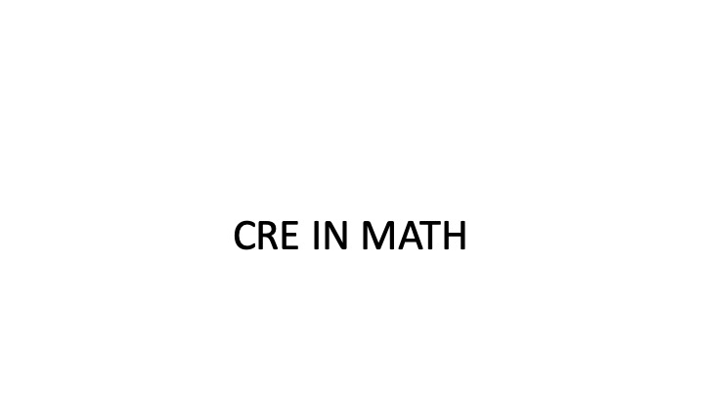
Slide 42 | 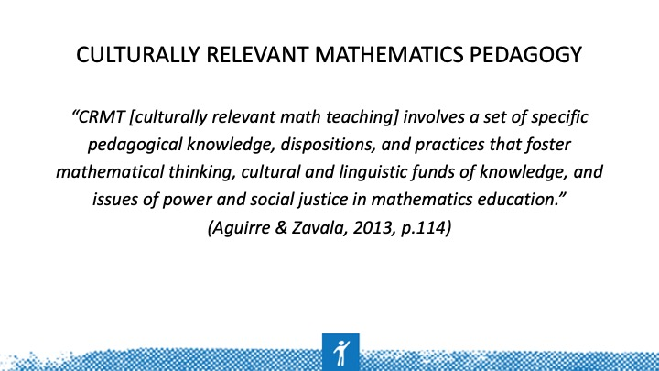 | Discuss how knowledge, dispositions (beliefs), and practices come together to draw on student knowledge and create a collaborative learning approach focused on mathematical thinking, not just math formulas and processes.  Discuss issues of power and justice in math (Aguirre & Zavala, 2013). CRTM combines CRT practices, pedagogical content knowledge of mathematics instruction to comprise culturally responsive mathematics teachers.
Slide 43 | 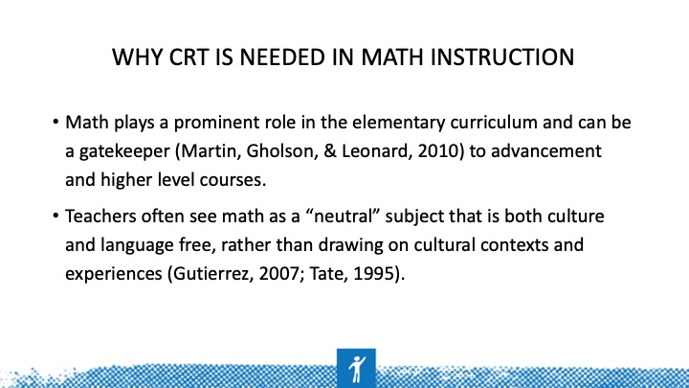 | Mathematics is an important content area for this work for two reasons. First, math plays a prominent role in the elementary curriculum and can be a gatekeeper (Martin, Gholson, & Leonard, 2010) to advancement and higher level courses. Second, prospective teachers (PSTs) often view school mathematics as a “neutral” subject that is both culture and language free rather than one that reflects particular cultural and sociopolitical contexts and ways of knowing (Gutierrez, 2007; Tate, 1995).
Slide 44 | 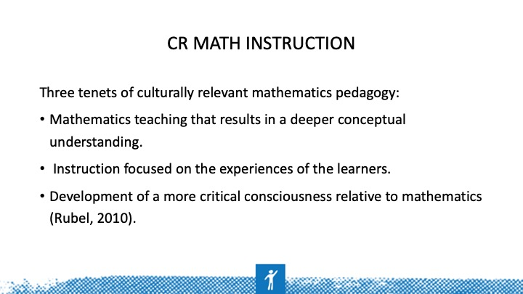 | According to Aguirre, Zavala, and Katanyoutanant (2012), culturally relevant mathematics pedagogy (CMRP) refers to “a set of specific pedagogical knowledge, dispositions, and practices that foster mathematical thinking, cultural and linguistic funds of knowledge, and issues of power and social justice in mathematics education” (p. 114).
Slide 45 | 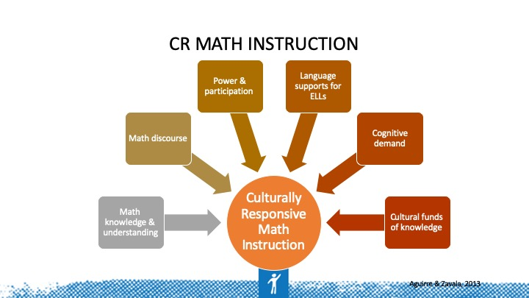 | According to Aguirre & Zavala (2013), CRMT is comprised of six elements that combine the essentials of CRT, teacher math expertise, and understanding and draw on student’s lived experience and perspectives they bring to class every day. The six elements include math knowledge and understanding, math discourse, power and participation, language supports for ELLs, attention to cognitive demand, and drawing on cultural funds of knowledge (CFoK). In their math lesson tool analysis tool, Aguirre & Zavala (2013) describe each of these six elements in detail and provide guiding questions to evaluate and enhance math lesson plans through a culturally responsive lens.
Slide 46 | 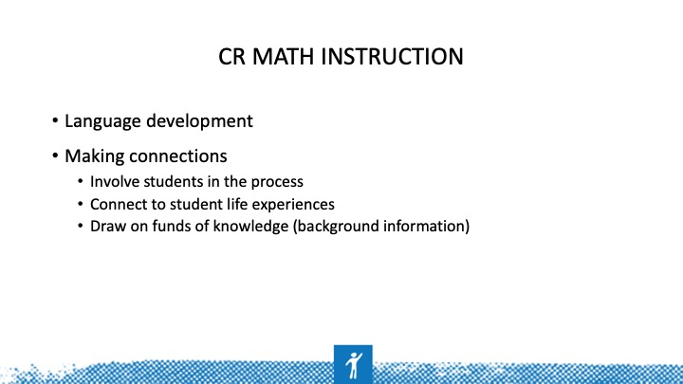 | So, how do EDUCATORS do this? For effective CR math instruction, educators should focus on language development and making connections to student lives to include involving students in the process of learning by offering choice or through other engagement strategies, connecting content to students life experiences, and drawing on funds of knowledge (background information) and valuing the knowledge and skills, both academic and non-academic skills, that students bring to the classroom.  Let’s talk about these in more detail.
Slide 47 | 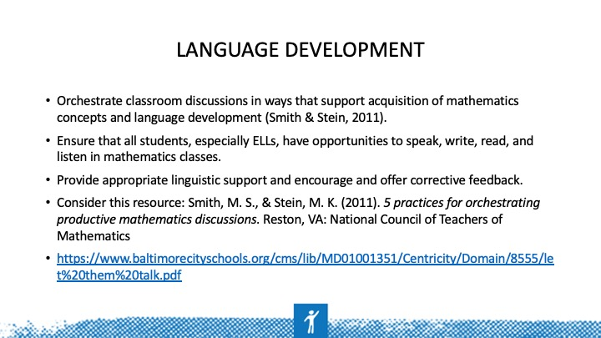 | These are a few ways teachers can facilitate language development:  Orchestrate classroom discussions in ways that support acquisition of mathematics concepts and language development (Smith & Stein, 2011). All students, but especially ELLs, must have opportunities to speak, write, read, and listen in mathematics classes with teachers providing appropriate linguistic support and encouragement.
Slide 48 | 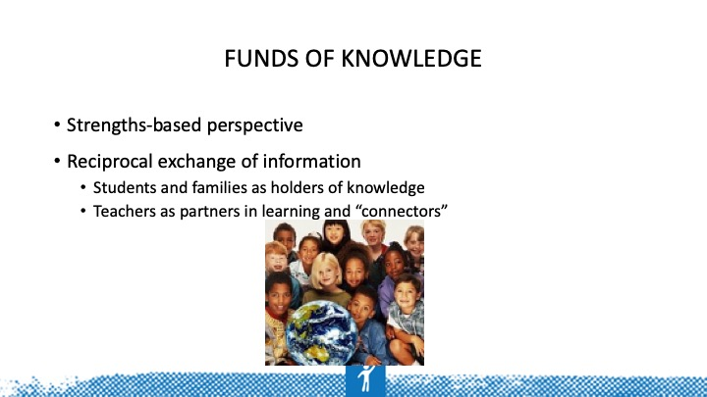 | Research on integrating CFoK in mathematics instruction suggests that teachers need to understand how CFoK — the historically and culturally based knowledge, skills, and practices found in students’ homes and communities — can support their mathematical learning (Civil, 2002; Gonzalez, Andrade, Civil, & Moll, 2001; Gonzalez, Moll, & Amanti, 2005; Moll, Amanti, Neff, & Gonzalez, 1992). Prior work has documented the positive impact of teachers’ drawing on CFoK on students’ participation and learning (Ladson-Billings, 2009; Turner & Celedon-Pattichis, 2011).
Slide 49 | 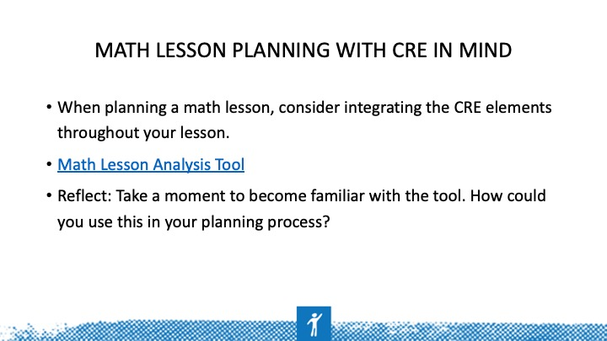 | Use this tool to plan and evaluate your math lesson. Reflect: How could you use this in your planning process? Would you use it in teams? Before or after teaching a lesson? Does it align with how you are currently planning for math lessons?
Slide 50 | 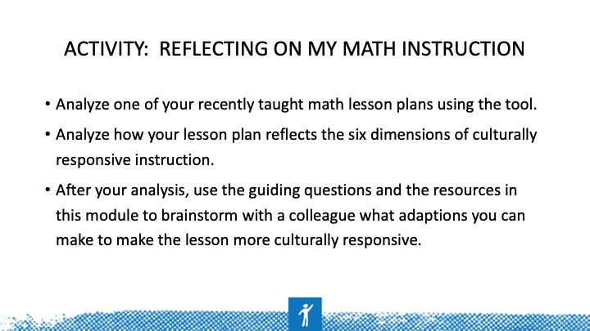 | Optional: To take this activity a step further, have a peer use the tool to give feedback on an observed lesson. Select one category from categories 1-3 and one from categories 4-6. Make a conscious effort to focus your instruction and feedback based on those selected categories.
Slide 51 | 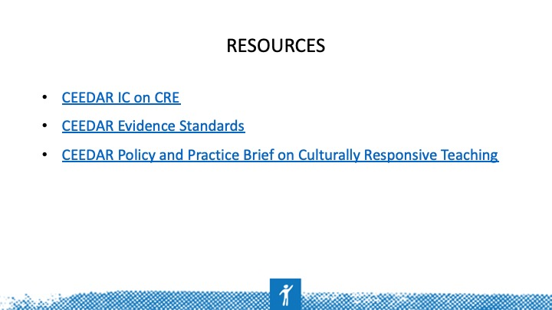 | Reminder of available CEEDAR tools and resources
Slide 52 | 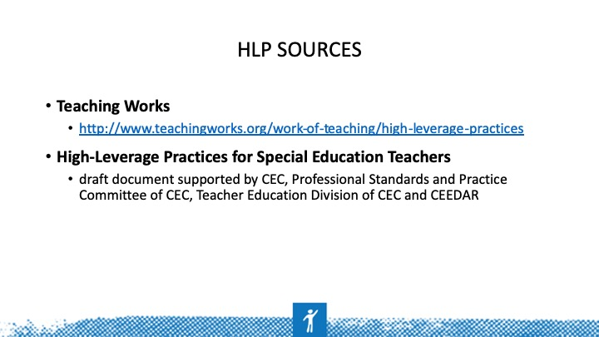
Slide 53 | 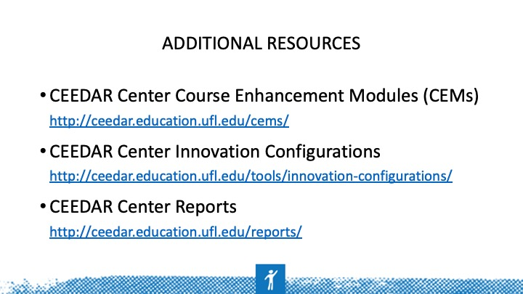
Slide 54 | 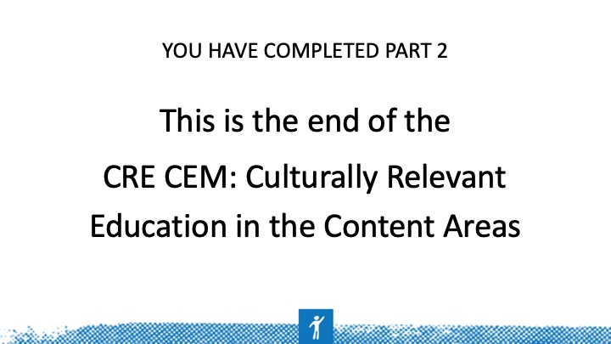
Slide 55

