Culturally Relevant Education:
Overview & Background

Overview and Speaker Notes

Intended Audience: Teachers in grades K-12 representing all content areas, including special education.

Overview for Facilitators:
The CEEDAR Center is pleased to provide the anchor presentation: Culturally Relevant Education: Overview & Background. The materials are designed to be included in a pre-service teacher preparation course or in-service teacher professional development program. This resource will increase in-service professionals’ ability to improve students’ readiness for college and careers.

Speaker Notes
The speaker notes are what the facilitator can say, verbatim, to explain each slide and the activities. Speaker notes are provided for most of the PowerPoint slides included. The notes provide additional details about the information presented in a particular slide, including the context for the information being presented as well as further elaboration of key points being discussed. The notes are provided as a guide, and speakers should feel free to modify these as needed.
- Text formatted in standard font is a sample script for the presenter. While these may be read verbatim, speaker notes are intended as a guide for the presenter and may be modified as needed.
- Text formatted in italics is intended as directions or notes for the facilitator; italicized text is not meant to be read aloud.

Materials Required
- Computers or tablets with internet access for participants (if possible)
- Handouts
- Projector with audio capable of playing video
- Large pieces of paper (for group use) and markers
- Presentation slides with speaker notes

Objectives: After participating in this professional learning opportunity, participants will be able to:
- Understand the evolution of culturally relevant education and related terms
- Be able to identify principles of culturally relevant education
- Begin to self-reflect about cultural identity and its influence on practice
- Understand the implications of teacher and student background on student outcomes

Outline of Session Activities and Approximate Time (Approximately 2 hours total)
Topic | Slides | Activity | Time
Introduction/Objectives | 1-3 |  | 5
Overview | 4 |  | 2
Who are You? | 5-6 | Cultural Identity Wheel (handout) | 10
Conceptions of Culture | 7-9 |  | 3
Defining Terms | 10-17 | Defining Terms (handout) | 20
Evolution of Culturally Relevant Education | 18-19 |  | 2
Culturally Responsive and Culturally Relevant Pedagogy | 20 | Video | 5
Culturally Relevant Pedagogy | 21 |  | 2
Culturally Responsive Teaching | 22-23 |  | 3
Culturally Sustaining Pedagogy | 24 |  | 2
Common Elements Across Culturally Relevant Pedagogy, Culturally Responsive Teaching, and Culturally Sustaining Pedagogy | 25-26 |  | 3
Culturally Relevant Education | 27-33 | School Research (handout) | 20
The Teacher and Students | 34-35 |  | 3
Implications for Students | 36-37 |  | 5
We Can All Be “Dreamkeepers” | 38 | Video | 3
Module Recap | 39 |  | 2

Speaker Notes with Slides

Slide 1 | 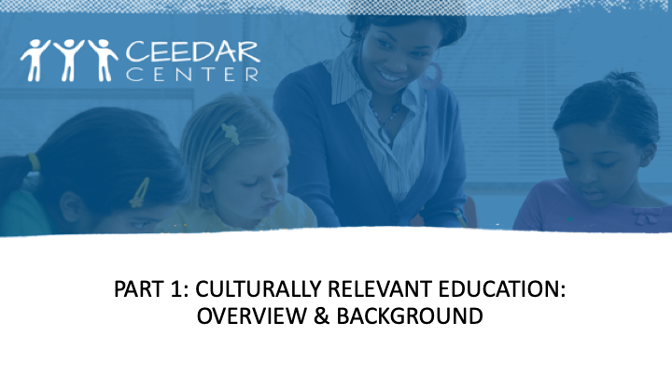 | Many terms refer to the need for educators to understand the diversity of race, culture, and ability. This Course Enhancement Module (CEM) focuses primarily on meeting the needs of racially and culturally diverse students in United States schools. The CEM on culturally relevant education (CRE) encompasses information from experts in culturally relevant pedagogy, culturally responsive teaching, and culturally sustaining pedagogy. The innovation configuration (IC) on culturally responsive teaching is an important resource that can be used to review courses and programs to identify inclusion of culturally responsive teaching essential components as well as opportunities to improve learning opportunities for professional development.
Slide 2 | 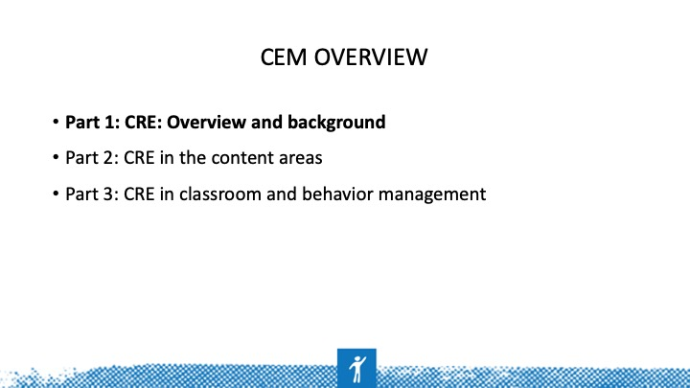 | This CEM is organized in three parts: overview and background, CRE in content, and CRE in classroom and behavior management. Some overlap exists between the overview and background and the other two parts.
Slide 3 | 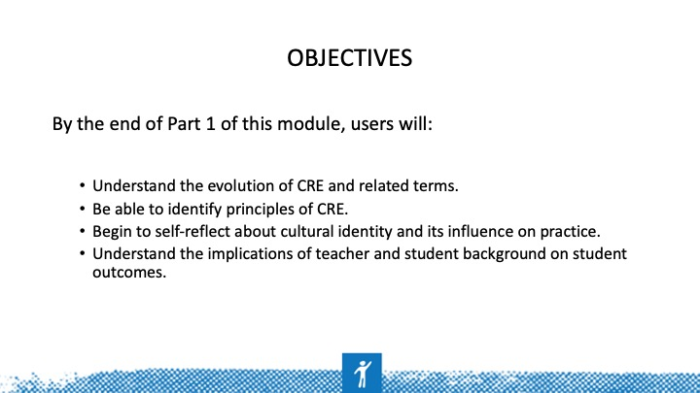 | Underlying questions posed in Milner (2010/2013, p. 2): (1) How do we design learning environments that build on the many talents and strengths that all P-12 students bring into the classroom? (2) Why do some teachers and students succeed while others do not?
Slide 4 | 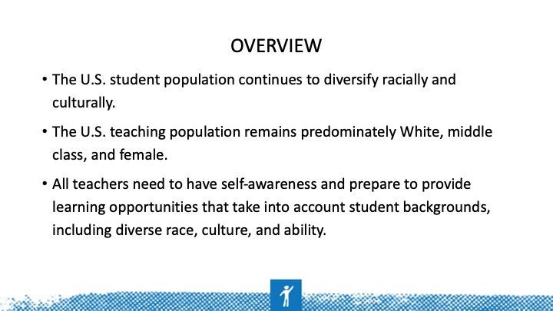
Slide 5 | 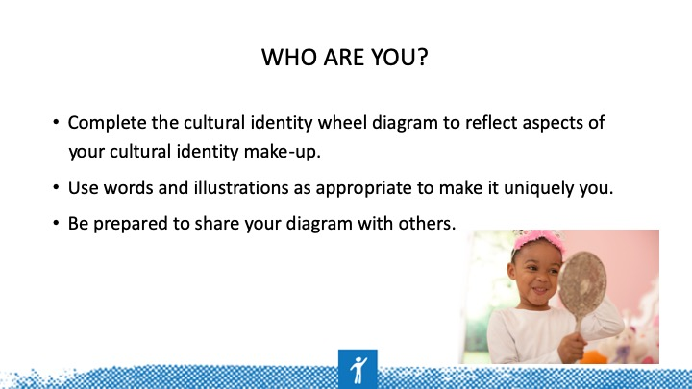 | ACTIVITY 1: See handout for template
Slide 6 | 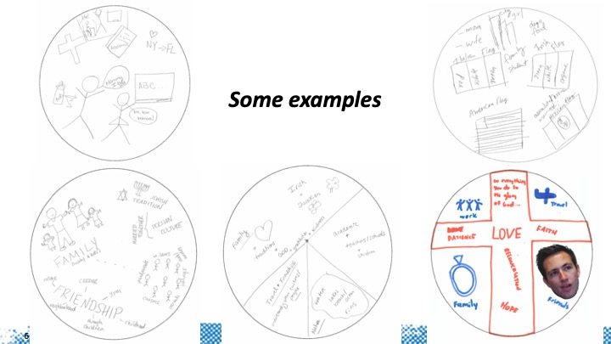 | What are the commonalities?  What are the differences?
Slide 7 | 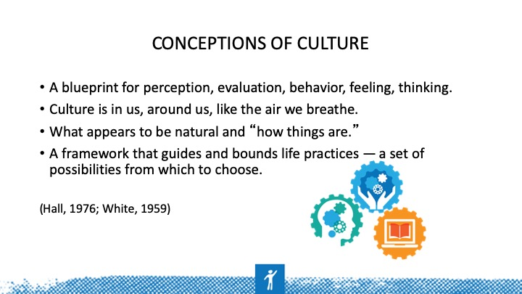 | Everyone has a culture. Many different people and researchers in different disciplines have observed various cultures and defined or characterized culture differently (White, 1959, Hall, 1976).  Culture used to mean refined ways of the elite and powerful: opera, art, fine wine, and food. Now, we have better definitions.  Learning about our own culture as individuals and professionals in special education will begin our journey to cultural competence and help to avoid some of the unfortunate experiences for children in our country. We will begin learning about multicultural education and ourselves this week.
Slide 8 | 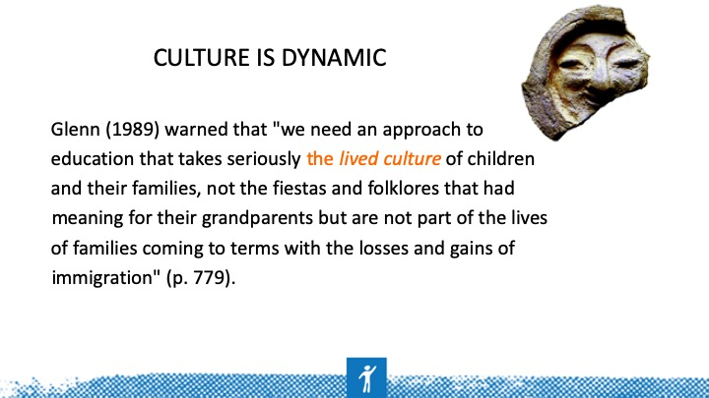
Slide 9 | 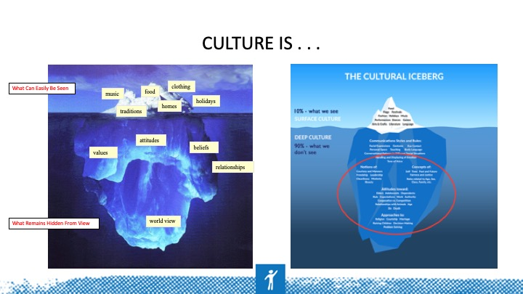 | Edward T. Hall’s (1976) iceberg model continues to be popular in all of its variations. The point is that aspects of culture and difference are visible and obvious while other elements are hidden from limited observation but are no less important. These below-the-surface values and characteristics can help us understand the depth of human individuality.
Slide 10 | 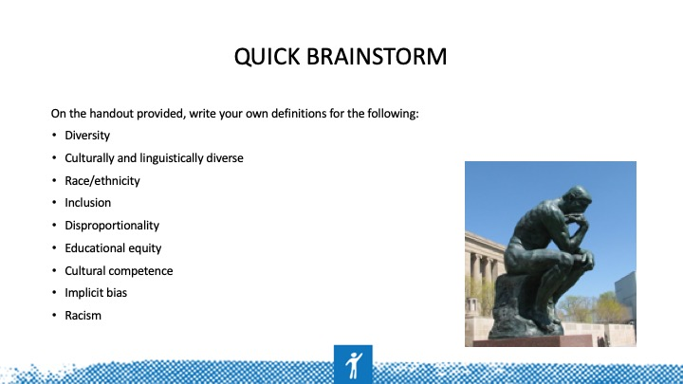 | Let’s take about 10 minutes to independently think about what these terms mean to us or how we have come to understand them. We’ll discuss them after we’ve taken this time to think.
Slide 11 | 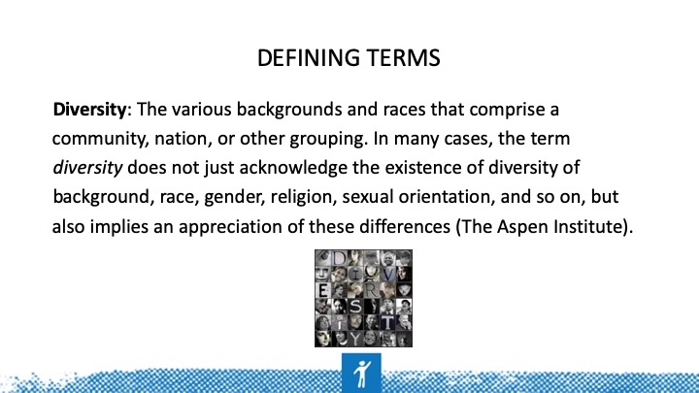
Slide 12 | 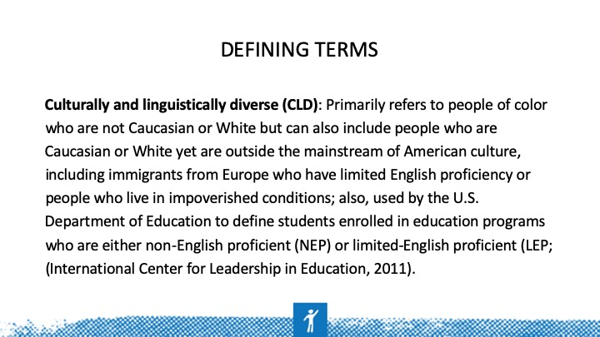
Slide 13 | 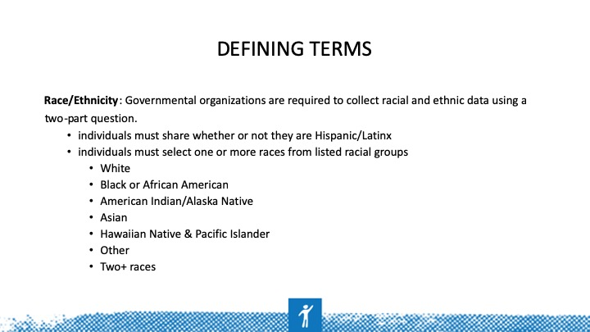
Slide 14 | 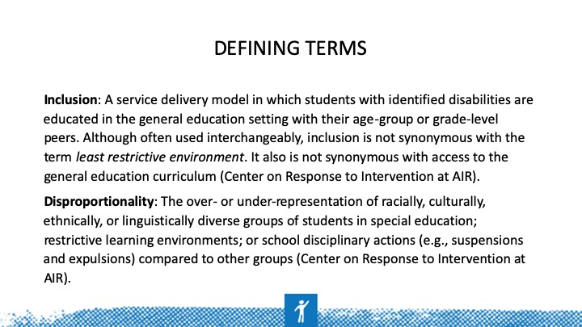
Slide 15 | 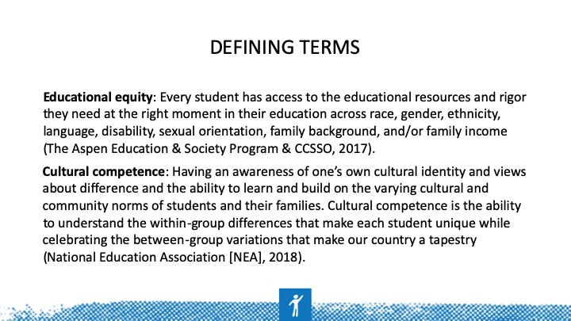
Slide 16 | 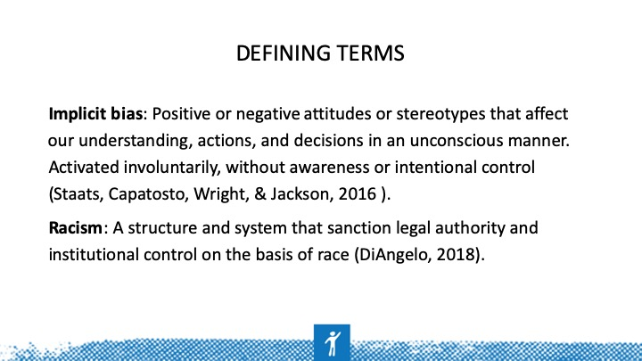
Slide 17 | 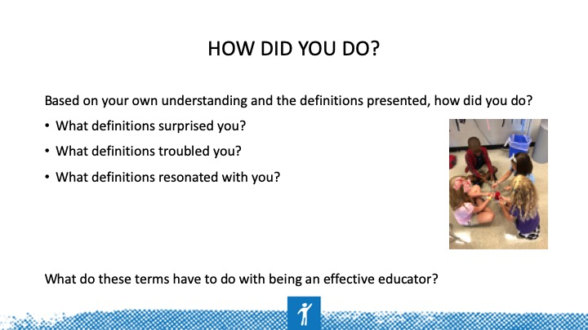
Slide 18 | 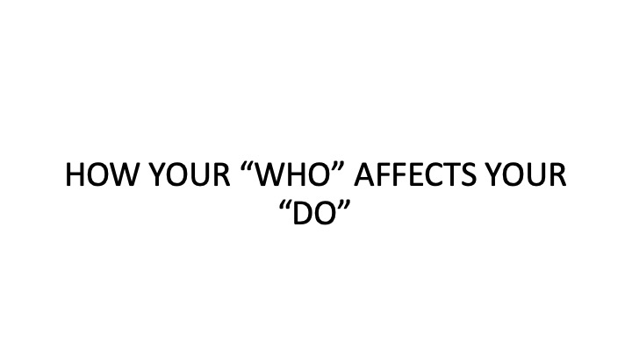
Slide 19 | 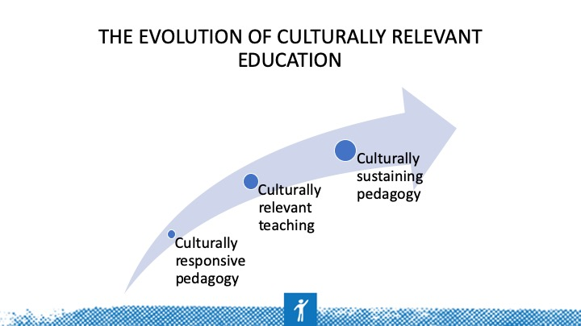 | In this section, we discuss some of the most commonly used terminology related to education intentionally designed to include and meet the needs of culturally, linguistically, and racially diverse learners. The term we use —culturally relevant education —encompasses elements common to the terms discussed here.
Slide 20 | 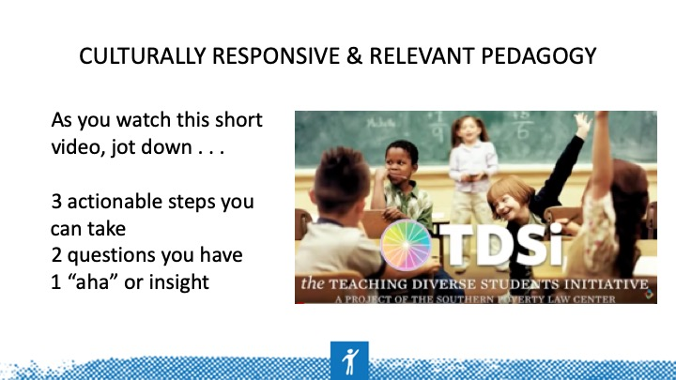 | Video: https://youtu.be/nGTVjJuRaZ8  ACTIVITY 2: See handout for this activity and slides that follow on culturally relevant teaching, culturally responsive pedagogy, and culturally sustaining pedagogy.
Slide 21 | 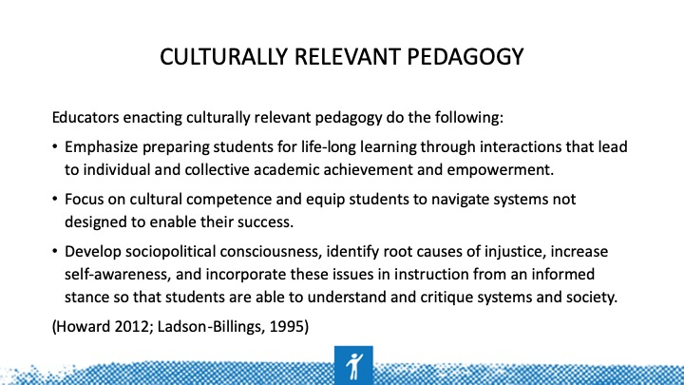
Slide 22 | 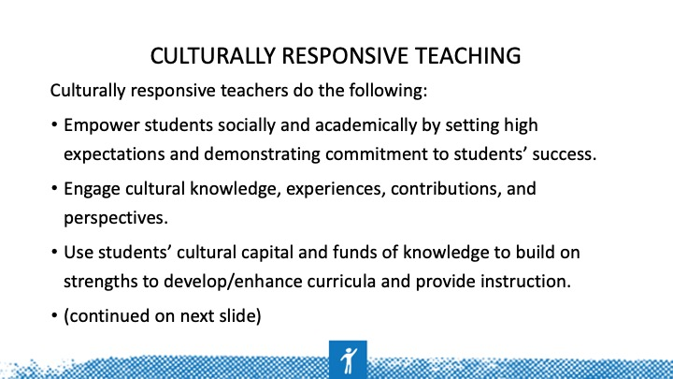
Slide 23 | 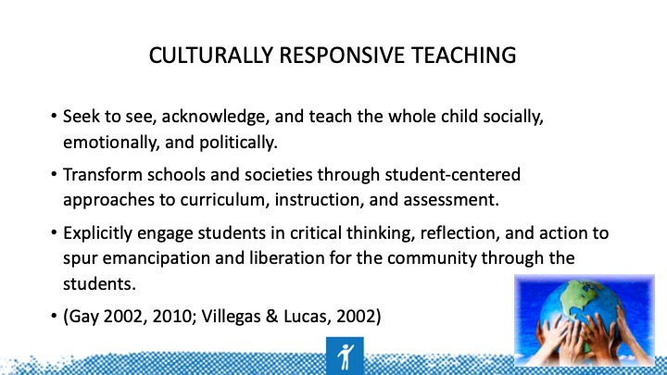
Slide 24 | 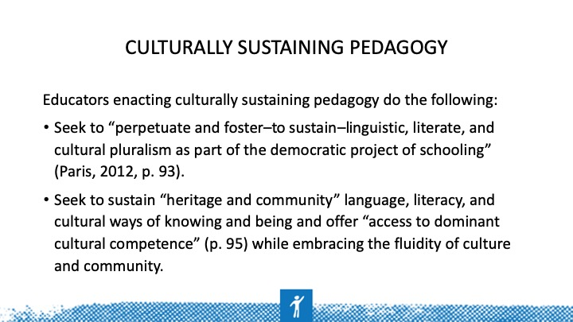
Slide 25 | 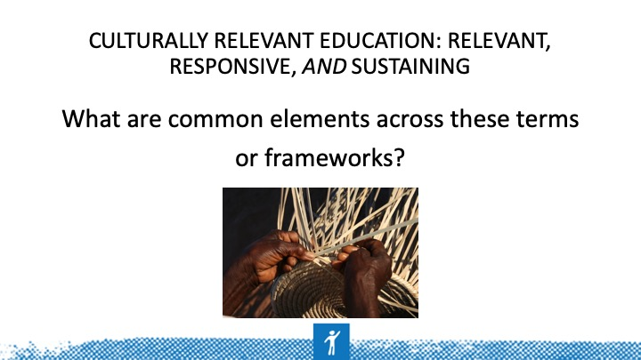 | The three unifying elements include intentional attention to academic achievement, awareness of and sensitivity to self and other, and critical analysis of systems and society.
Slide 26 | 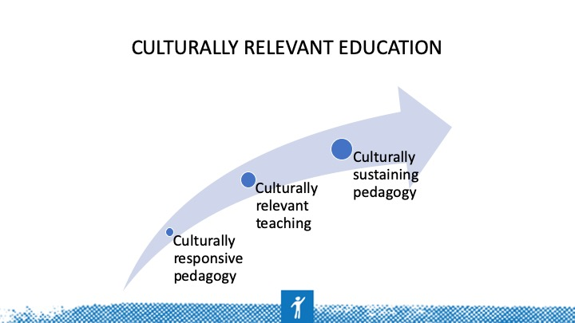 | This figure represents the trajectory of terminology while the intent remains the same — providing an equitable educational opportunity by affirming and including the cultural backgrounds of diverse learners.
Slide 27 | 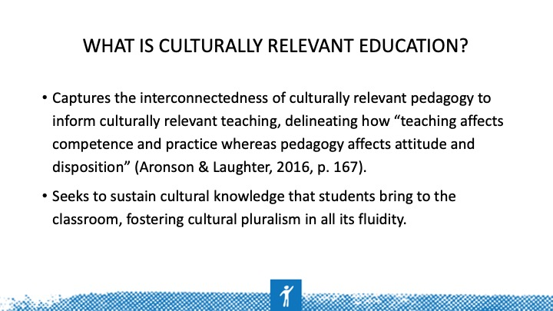 | Your “who” affects what you “do.”
Slide 28 | 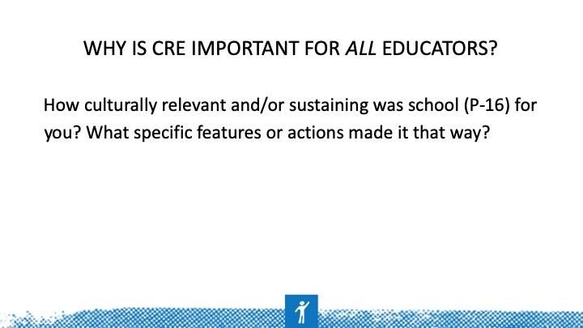 | Take 5 minutes to brainstorm/jot down examples of how your P-16 learning opportunities were culturally relevant/sustaining. What made them relevant/sustaining?  Share with a peer who is different (e.g., race/culture, gender) in some way.
Slide 29 | 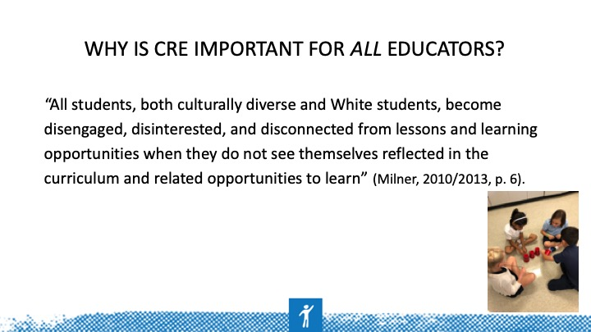 | CRE is important for all teachers because it matters for all students. Every adult in the school building has an influence on the learning of each child. Principals are responsible for the overall operations and interactions within the building and should be providing leadership and vision that supports CRE. Teachers and related services/instructional personnel have closer contact and accountability for student learning, which includes social-emotional learning (touched on in Part 3 of this CEM).
Slide 30 | 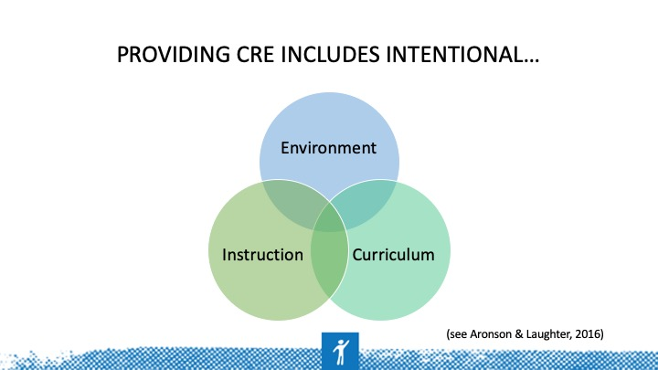 | Take 5 minutes to quickly brainstorm/jot down strategies for implementing CRE in environment, instruction, and curriculum.
Slide 31 | 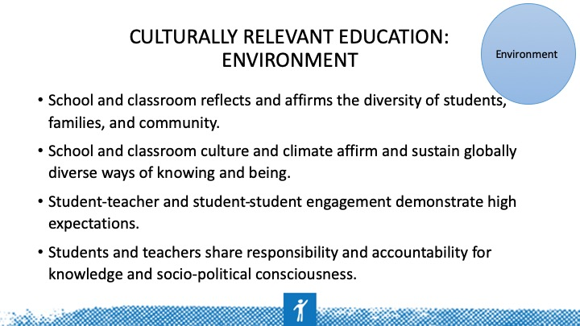 | Work with a partner/small group (preferably someone you don’t usually work with) to place your strategy in one of these areas. Can you identify an additional strategy area that you don’t see listed? Place a star by it to share with the group.
Slide 32 | 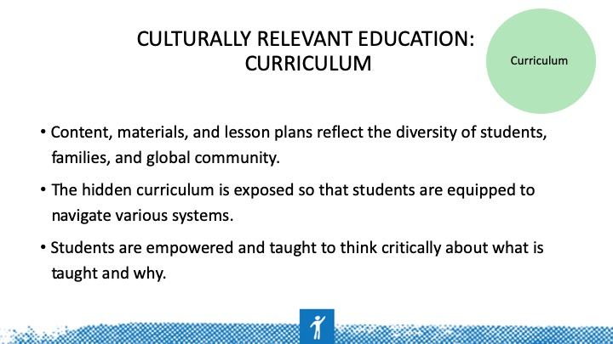 | Work with a partner/small group (preferably someone you don’t usually work with) to place your strategy in one of these areas. Can you identify an additional strategy area that you don’t see listed? Place a star by it to share with the group.  ACTIVITY 3: See Anyon (1980) to have a deeper discussion of the hidden curriculum and the implications for student outcomes.
Slide 33 | 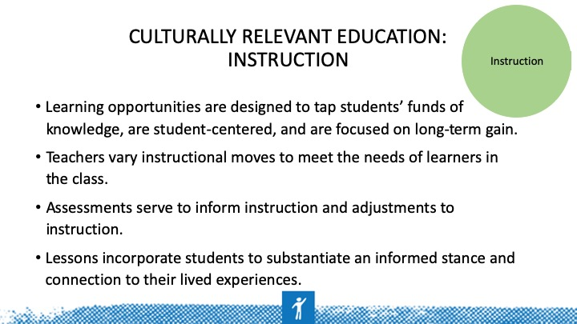 | Work with a partner/small group (preferably someone you don’t usually work with) to place your strategy in one of these areas. Can you identify an additional strategy area that you don’t see listed? Place a star by it to share with the group.  For more on funds of knowledge, see Gonzalez, Moll, and Amanti (2005), who conceptualize funds of knowledge: People are competent, they have knowledge, and their life experiences have given them that knowledge (p. ix-x).
Slide 34 | 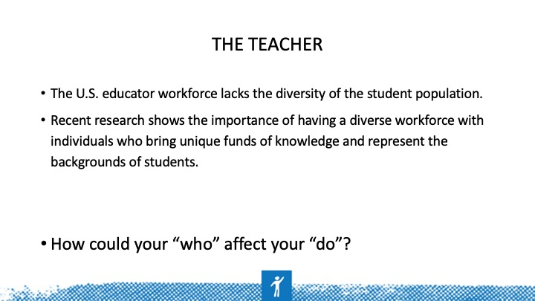 | Let’s revisit our cultural identity wheels — how do the attributes/values on your wheel provide potential for dis/connect with students?
Slide 35 | 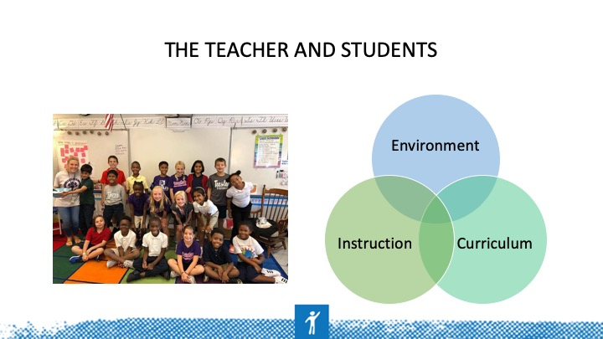 | What are some individual differences we might need to be aware of and intentional about addressing BEFORE we enter the classroom? How might these differ based on school context and student demographics?  Think about student funds of knowledge as well as your own. Consider these whether you’re in a high-/low-poverty, rural, urban, or suburban school with a majority White/Black/Latinx or diverse population. How do the various factors make you think differently about the environment, curriculum, and instruction?
Slide 36 | 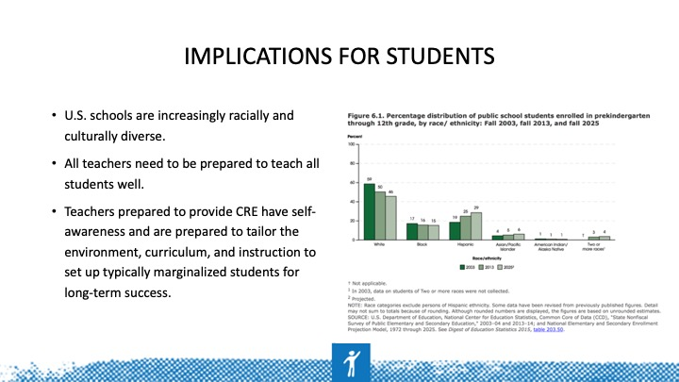 | If teachers and leaders are not prepared and held accountable for meeting the needs of all learners, disproportionality will continue to be a problem for racially and culturally diverse learners.
Slide 37 | 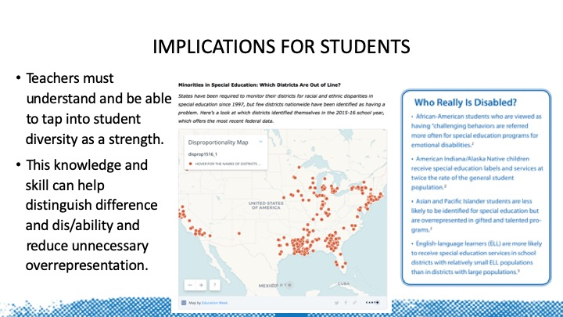 | On 1/25/18, EdWeek published an article including an interactive map. Map: Minorities in special education: Which districts are out of line?  https://www.edweek.org/ew/section/multimedia/map-minorities-in-special-education-which-districts.html  According to the 39th Annual Report to Congress on the Implementation of the Individuals with Disabilities Education Act (U.S. Department of Education, 2017), the risk ratios for receiving special education services were as follows: American Indian/Alaska Native, 1.7; Native Hawaiian/Pacific Islander, 1.5; Black/African American and Hispanic/Latinx, 1.4; White and two or more races, 0.9; and Asian, 0.5.
Slide 38 |  | Dr. Gloria Ladson-Billings has long been a champion of culturally relevant pedagogy. In this video, she shares qualities of educators who found success with African-American students.  Video: https://youtu.be/hmAZjNRmalI
Slide 39 | 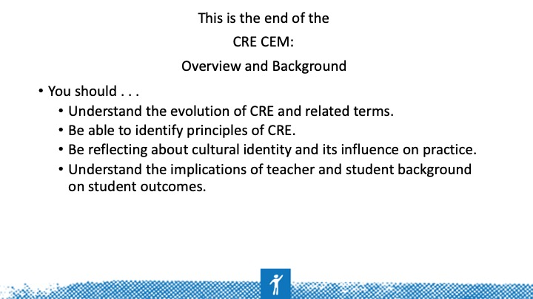
Slide 40 | 