Culturally Responsive Classroom
Management

Overview and Speaker Notes

Intended Audience: Teachers in grades K-12 representing all content areas, including special education.

Overview for Facilitators:
The CEEDAR Center is pleased to provide the anchor presentation: Culturally Responsive Behavior Management. The materials are designed to be included in a pre-service teacher preparation course or in-service teacher professional development program. This resource will increase in-service professionals’ ability to improve students’ readiness for college and careers.

Speaker Notes
The speaker notes are what the facilitator can say, verbatim, to explain each slide and the activities. Speaker notes are provided for most of the PowerPoint slides included. The notes provide additional details about the information presented in a particular slide, including the context for the information being presented as well as further elaboration of key points being discussed. The notes are provided as a guide, and speakers should feel free to modify these as needed.
- Text formatted in standard font is a sample script for the presenter. While these may be read verbatim, speaker notes are intended as a guide for the presenter and may be modified as needed.
- Text formatted in italics is intended as directions or notes for the facilitator; italicized text is not meant to be read aloud.

Materials Required
- Computers or tablets with internet access for participants (if possible)
- Handouts
- Projector with audio capable of playing video
- Large pieces of paper (for group use) and markers
- Presentation slides with speaker notes

Objectives: After participating in this professional learning opportunity, participants will be able to:
- Understand what culturally responsive classroom management is and is not
- Understand how their biases impact how they manage their classrooms and the behavior of their students
- Understand the difference between schoolwide, classroom, and individual strategies to address culturally responsive classroom management
- Understand the implications for students and teachers

Outline of Session Activities and Approximate Time
Topic | Slides | Activity | Time
Introduction/Objectives | 1-4 |  | 2 minutes
What CRCM is | 5-6 |  | 4 minutes
Diversity | 7-9 | Thinking, Feeling, Saying, Doing | 12 minutes
Cultural Proficiency | 10-12 | Where are you on the continuum? | 8 minutes
5 Essential Elements | 13 |  | 2 minutes
Teacher Perceptions & Implicit Bias | 14-16 | Implicit Bias Test | 25 minutes
Multicultural Education | 17-19 |  | 5 minutes
Teacher Biases | 20 |  | 2 minutes
Schoolwide Strategies | 21-34 | Restorative Justice Video & CASEL SEL Video | 40 minutes
Classroom Strategies | 35-42 |  | 8 minutes
Individual Strategies | 43-46 | Behavioral Contract (link) | 15 minutes
Implications for Student Outcomes | 47-48 |  | 3 minutes
Implications for Teacher Outcomes | 49-51 | Rank order teacher outcomes | 7 minutes

Speaker Notes with Slides

Slide 1
Slide 2 | 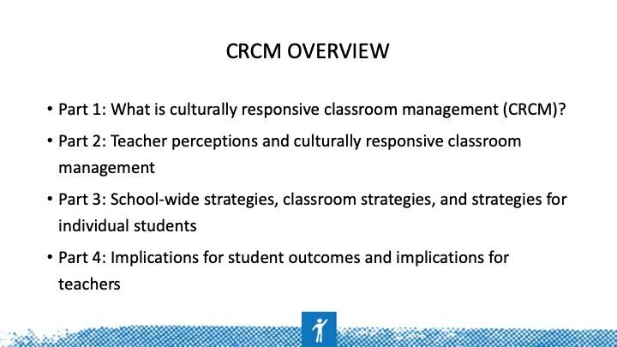
Slide 3 | 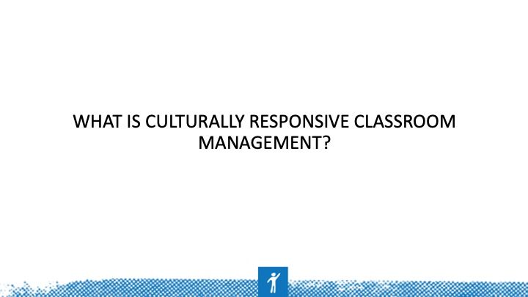
Slide 4 | 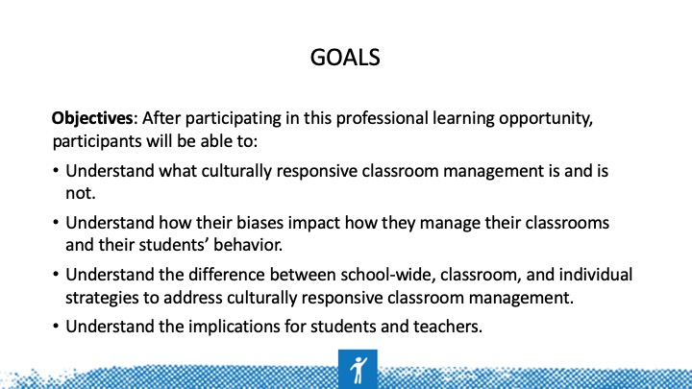 | You will learn the following four big takeaways from this portion of the presentation.  1. You should know how to define CRCM.  2. You should know how your perceptions of your students impact how you manage their behavior.  3. You should know what school-wide, classroom, and individual CRCM strategies are and how they differ.  4. You should be able to share how using CRCM strategies benefits student outcomes and how they improve your practice.
Slide 5 | 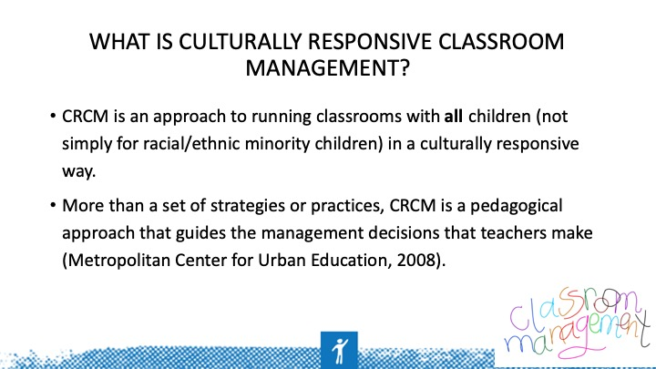 | Why do you think the point is made that CRCM is more than strategies or practices? Why is this distinction important to point out? Possible talking points: It's what your belief system is, the biases you carry, etc. It's similar to what you believe about how children learn. Do you think all children can learn or just some? Do you think you can positively manage all students' behavior can, or do you think you have to be mean to get the attention of students of color? It's all in your mindset and what you believe about the behavior of students of color.
Slide 6 | 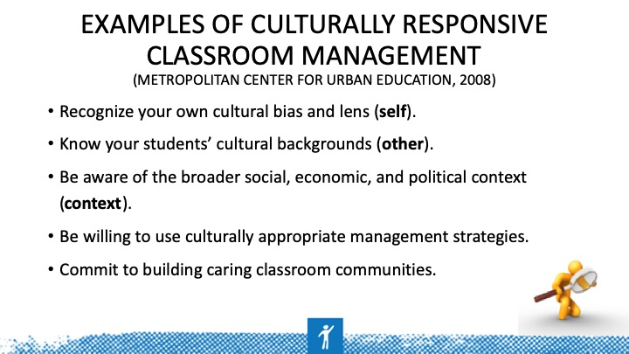 | Always start with yourself. Who are you? What do you believe? How do you view those with different backgrounds than you? How can you learn about your students' backgrounds in a meaningful way and in a way that let's them know that you care about who they are outside of school? How does what's going on in the community and our state, nation, and world impact what we do in classroom? How does the SES of your students' parents impact what happens in the classroom? How do issues such as immigration, police brutality, etc impact the dynamics of your classroom? How does policy set by the federal and state government impact what happens in your classroom and your students? Be open to doing things differently when it comes to managing the behavior of your students of color. Be willing to next out of your comfort zone if need be. Make sure that every student in your classroom feels as if they belong in your classroom. Build positive and meaningful relationships with each student. If this goal is met, the academics will take care of itself. Remember, students don't care how much you know until they know how much you care.
Slide 7 | 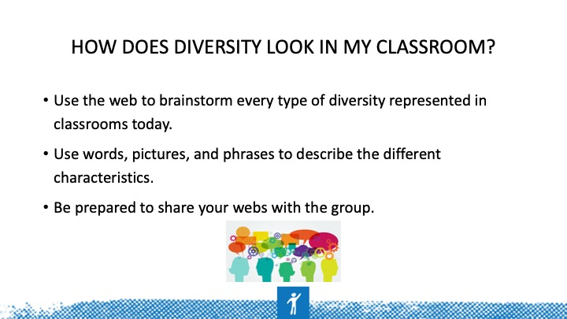 | Think in terms of culture; language; learning needs (e.g., gifted, special education, struggling learning); racial/ethnic background; SES; gender; sexual orientation; and religion.
Slide 8 | 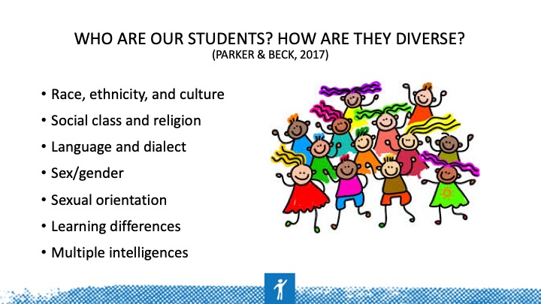 | Would you add any group to this list? If so, which group is missing? How many of these different groups are represented in your classrooms? How? How do these groups impact how you manage your classroom?
Slide 9 | 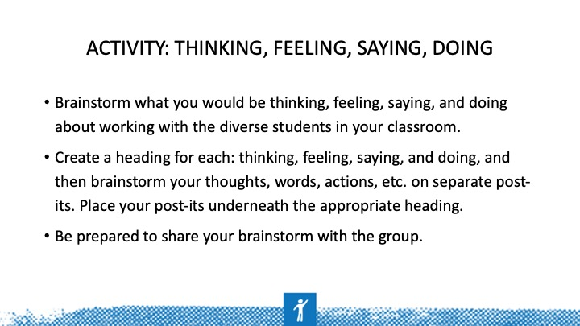 | Each group should have a different heading. For example, Group 1 (thinking), Group 2 (feeling), Group 3 (saying), Group 4 (doing). If you have more than four groups, repeat headings until each group has one. Give each group post-its on which to brainstorm thoughts, and then have them place their post-its on their poster and hang the posters on the wall around the room. Then, the participants will complete a walk-about of all of the posters. They will pull post-its to take back to their seats that they feel they need to discuss further. Facilitate a whole-group discussion of brainstorms through participants sharing the post-its that they brought back to their seats.
Slide 10 | 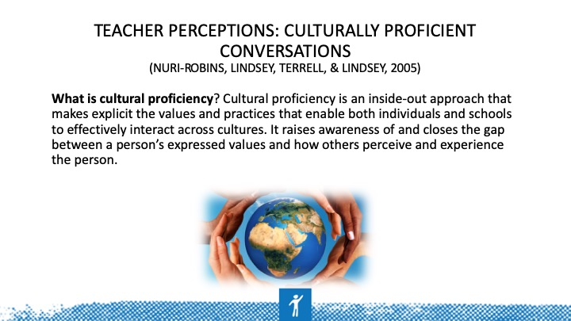 | View cultural proficiency as a way to understand, embrace, and talk about differences that recognizes and respects individuals and their cultures. To achieve this task, educators must align their values and educational philosophies with their daily practices to create learning communities among and between educators, students, and their families. This model focuses on middle and high schools, but elementary administrators and teachers can easily adopt these principles.
Slide 11 | 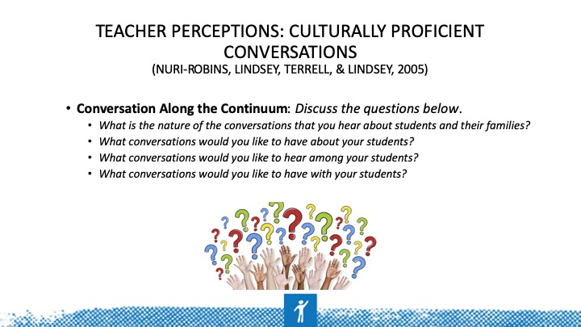 | Notice that the key in all of these questions is communication. What are you hearing/saying? What are your students hearing/saying? Having these conversations are key to building cultural proficiency.
Slide 12 | 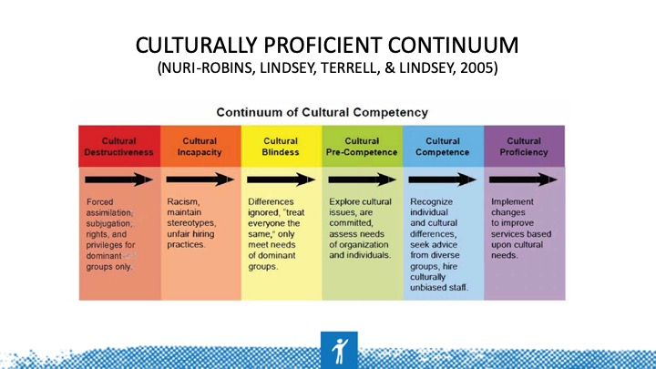 | Discuss this question with your table. Be honest and reflective. If you aren't where you'd like to be, what are some practical changes you can make to get to where you'd like to be on the continuum. Be prepared to share where your group members are on the continuum and why each person felt that way. Choose a spokesperson to share this information.
Slide 13 | 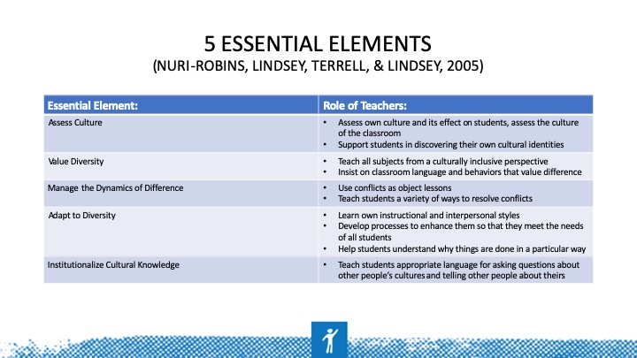 | An important point for you and your students to know is that we all have a cultural identity—not just ethnically/linguistically diverse groups, but all groups have a cultural identity. You have to be aware of your identity to understand and value another group's identity. By creating culturally inclusive lessons, you will show your students that you value who they are and where they come from, which goes a long way toward curtailing behavior problems and building strong relationships with your students. As the saying, "Physician heal thyself” goes, so should "Teachers know thyself so that you can know your students." Model appreciation for different cultures and languages for your students and teach them how to appropriately ask others about their cultures without offending.
Slide 14 | 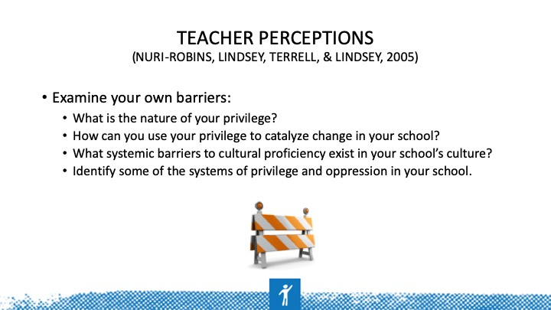 | Be honest and reflective in how you answer these questions.
Slide 15 | 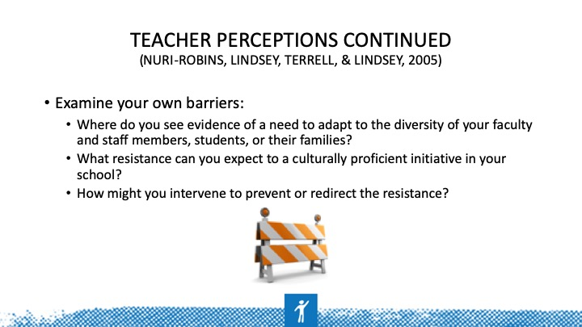
Slide 16 | 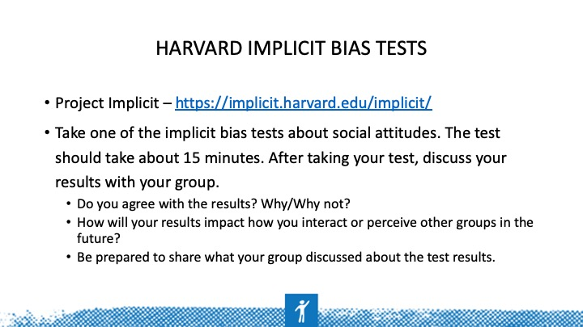 | Choose a spokesperson to share a synopsis of what your table discussed about the IAT.
Slide 17 | 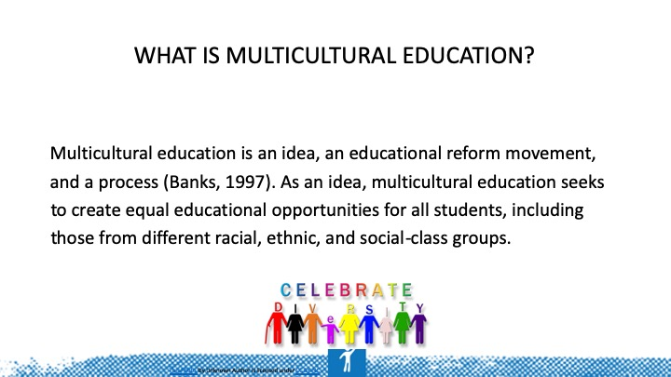
Slide 18 | 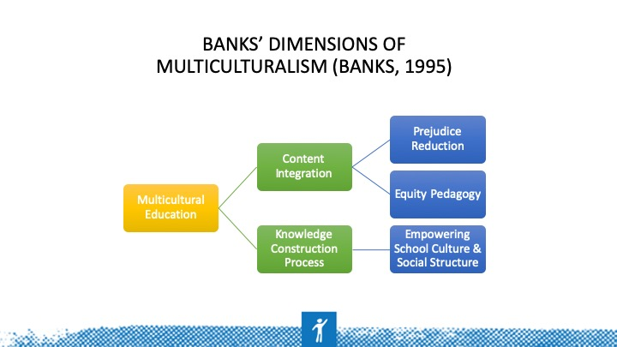
Slide 19 | 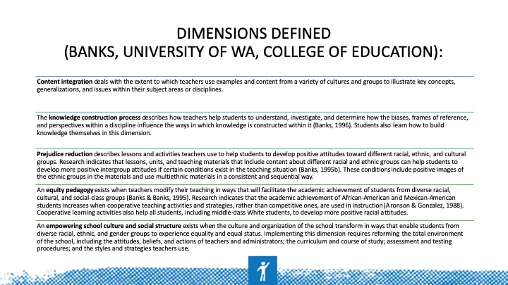
Slide 20 | 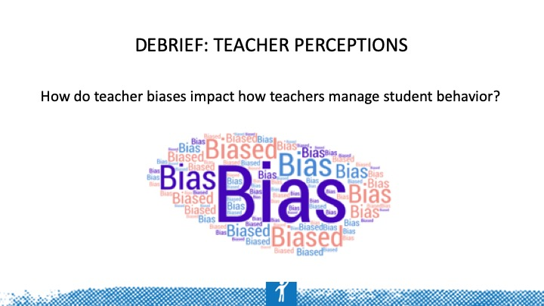 | How does what you believe about different cultural groups impact how you manage students' behavior from those groups? Are you always fair and equitable when managing behaviors? Are you more patient with certain students because they are more similar to you?
Slide 21 | 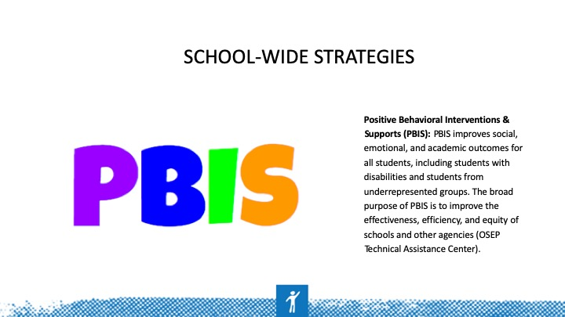 | Key point: Focus is not just on academic outcomes, but also on social and emotional outcomes. How and why is this focus beneficial to the students? How is Positive Behavioral Interventions & Support (PBIS) an equitable practice based on the definition and purpose of PBIS?
Slide 22 | 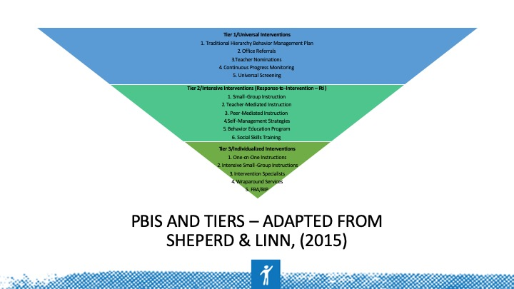 | Just as tiers for academic learning exist, with PBIS, the tiers relate to different ways to address the behavioral needs of students. Just as with the academic tiers, continuous progress monitoring for students is part of the tier system for behavior. Response to Intervention (RtI) has transitioned to Multi-Tiered System of Supports (MTSS). MTSS is defined as "the practice of providing high-quality instruction and interventions matched to student need, monitoring progress frequently to make decisions about changes in instruction or goals, and applying child response data to important educational decisions" (Batsche et al., 2005). Retrieved from https://www.pbis.org/school/mtss
Slide 23 | 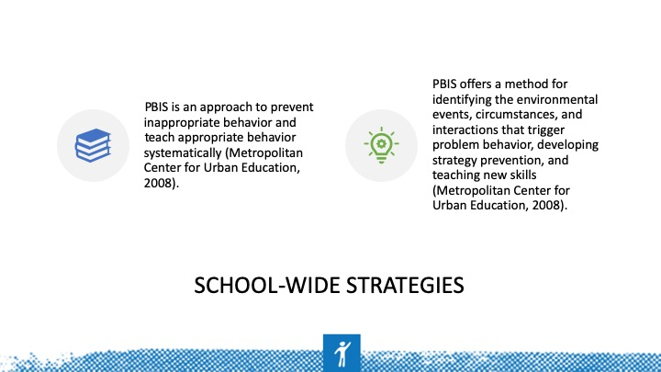 | Many factors within students’ environments can impact their behavior in the classroom. Knowing these factors allows the teacher to prevent certain behaviors by knowing triggers while allowing the teacher to teach students new skills to control their own behavior. Another key is to systematically teach these skills in a very specific manner.
Slide 24 | 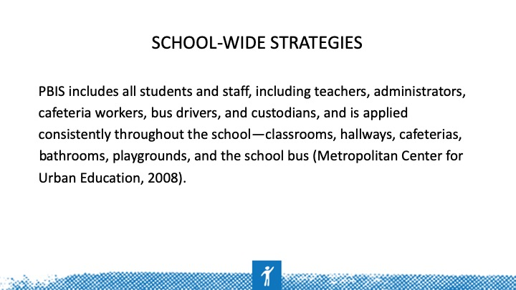 | This practice brief provides information on PBIS in the classroom: https://www.pbis.org/Common/Cms/files/Forum15_Presentations/RDQ%204%20Brief%20-%20Classroom.pdf
Slide 25 | 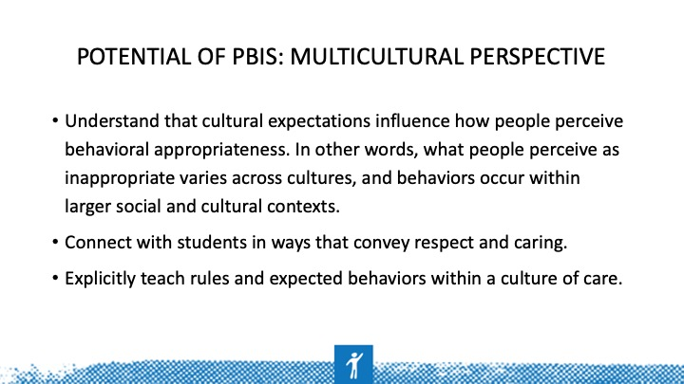 | Example of cultural appropriateness or inappropriateness: You expect students to participate in a lesson in which they question what you are telling them. You chastise the students for not asking questions when their culture teaches them that they do not question the teacher in school.  Example 2: You indirectly suggest that students should consider adding an illustration to their writing with the expectation that they will, but several of your students of color do not add the illustration. You penalize them for not adding the illustration when they felt that they did not have to add the illustration because you did not explicitly state that you wanted them to add an illustration.  Both are examples of cultural expectations (i.e., respect for the teacher by not questioning and expecting explicit directions versus an indirect message).
Slide 26 | 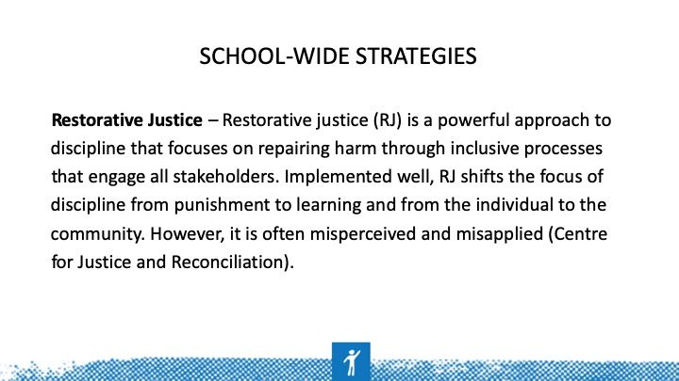
Slide 27 | 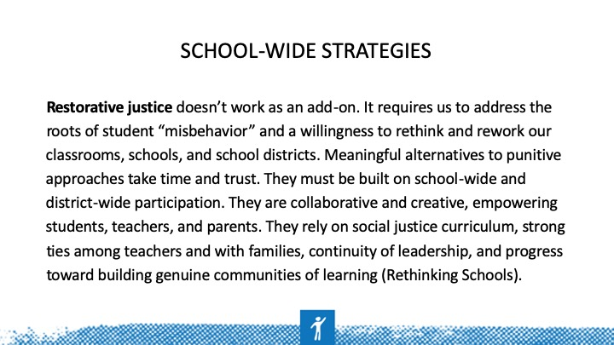 | Key point: district wide >>>>> school-wide (both must commit to this strategy); does not focus on punishing and addresses the root cause of student misbehavior (Why is the student acting out?)
Slide 28 | 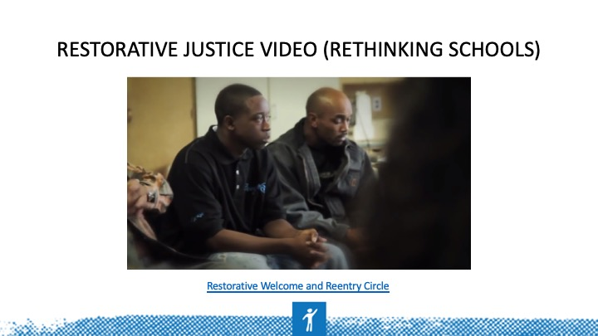 | Notice the number of people who are in this group to support the student’s return to school. Knowing that he has this many people in his corner helps him positively transition back to school and alleviates potential behavior problems that could occur.
Slide 29 | 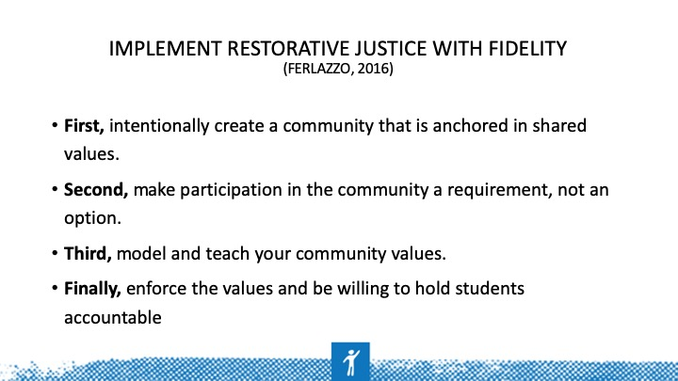 | First: Provide a common language for students, parents, and teachers to understand what is expected of all members of the school community. June Jordan School for Equity uses the acronym RICH to describe its four core values: Respect, Integrity, Courage, and Humility.  Second: Lots of items are necessary in schools: No. 2 pencils, backpacks, binders. Why can't you ask every student to adopt the core values that signify membership in your sacred community? Think of this as benevolent branding: "This is a special place where you want to belong." Requiring students to participate in the community means a couple of things. First, they must do their best to practice its values in word and deed.  Second, they commit to engage in restorative processes if they have harmed the community or another member harms them. A reciprocal principle is implied here: We will keep you safe, but in return, you have to show up as a full participant.  Third: We know that students need four to 40 exposures to learn a new vocabulary word. Internalizing your school's values is no different. Leverage your most personalized school structures—advisory, circle time, community-building days—to explicitly teach the values of your beloved community. Take time to teach in interactive ways like role-playing, reading and writing stories about the values in action, and asking students to recall their life experiences related to the values.  Finally: A cookie-cutter approach to restorative justice does not exist. You are asking students to make a commitment to stay in a relationship with each other and their community. By extension, if they violate or harm that relationship, they need to make amends. Accountability might look like a verbal "talking-to," having to reflect on choices in a restorative circle, engaging in a restorative conference with the harmed party, or perhaps even being suspended. Real, felt consequences along with opportunities to make amends and learn from mistakes are necessary. A helpful guiding principle is that consequences should always be educational in nature rather than punitive. Matt offers, "I don't care about the quantity of suspensions; I care about the quality.”  Second: Lots of things are required in schools: Number 2 pencils, backpacks, binders. Why can't you ask every student to adopt the core values that signify membership in your sacred community? Think of this as benevolent branding: "This is a special place where you want to belong." Requiring students to participate in the community means a couple of things. First, they must do their best to practice its values in word and deed. Second, they commit to engage in restorative processes if they have harmed the community or been harmed by another member. There is a reciprocal principle implied here: We will keep you safe, but in return you have to show up as a full participant.  Third: We know that it takes students four to 40 exposures to learn a new vocabulary word. Internalizing your school's values is no different. Leverage your most personalized school structures--advisory, circle time, community-building days--to explicitly teach the values of your beloved community. Take time to teach them in interactive ways like role-playing, reading and writing stories about the values in action, and asking students to recall their life experiences related to the values.  Finally: There's no cookie cutter approach to restorative justice. You are asking students to make a commitment to stay in relationship with each other and their community. By extension, if they violate or harm that relationship, they need to make amends. Accountability might look like a verbal "talking-to," having to reflect on their choices in a restorative circle, engaging in a restorative conference with the harmed party, or perhaps even being suspended. There must be real, felt consequences along with opportunities to make amends and learn from mistakes. A helpful guiding principle is that consequences should always be educational in nature rather than punitive. Matt offers, "I don't care about the quantity of suspensions, I care about the quality.”
Slide 30 | 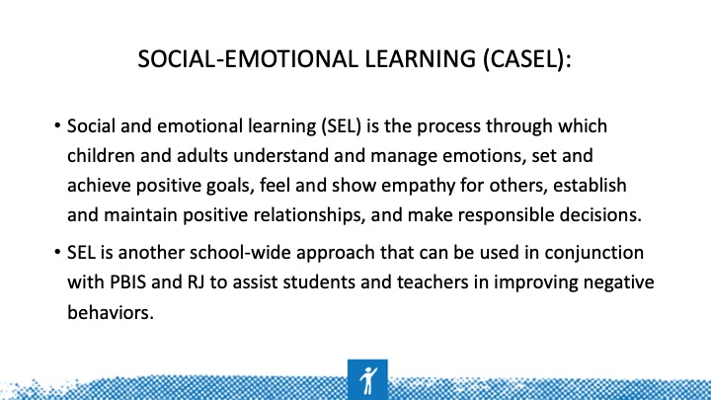
Slide 31 | 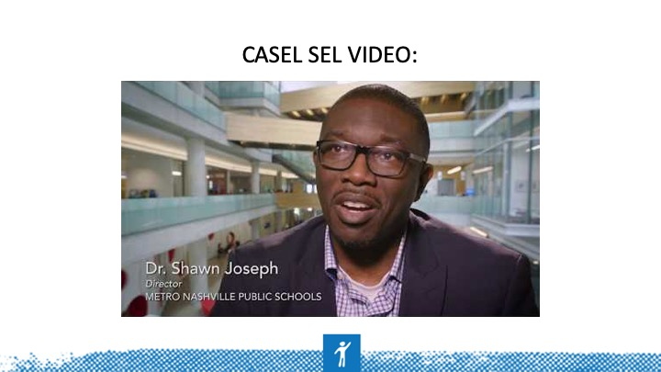
Slide 32 | 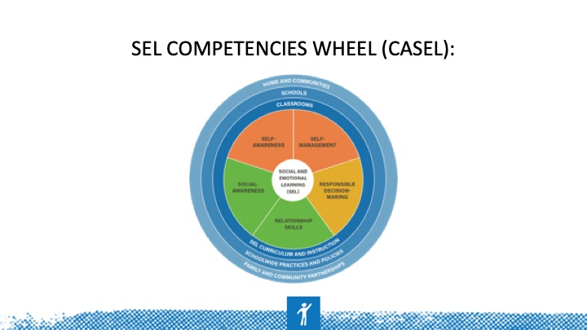
Slide 33 | 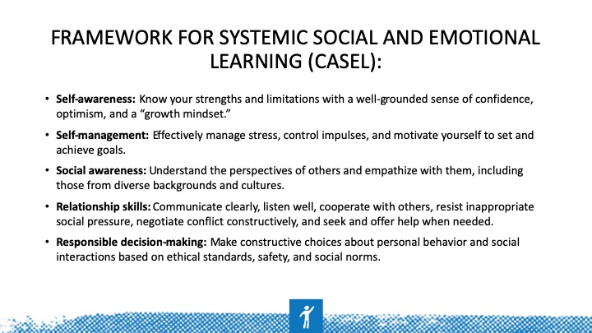
Slide 34 | 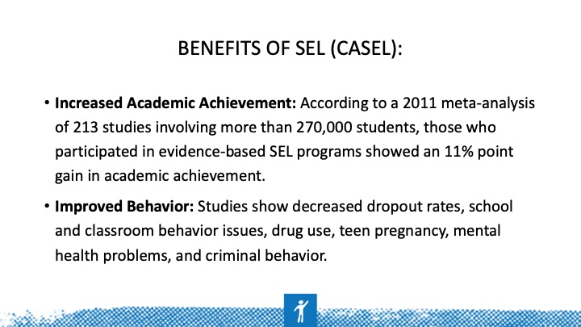
Slide 35 |  | Although you don't have to create a special handshake for each of your students, greeting them at the door daily is an easy way to build relationships. This practice also clues you in to who will have a good/bad day and allows you prevent students from exhibiting negative behaviors by turning their day around before they enter the class.
Slide 36 | 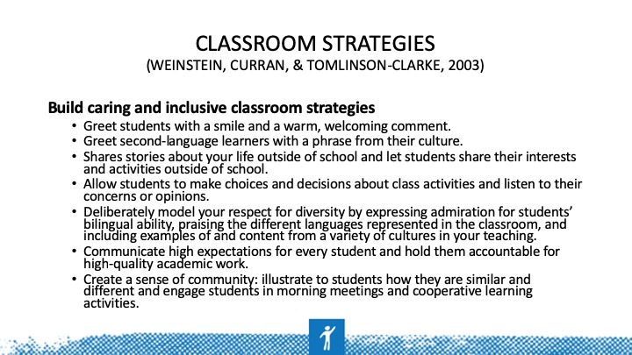
Slide 37 | 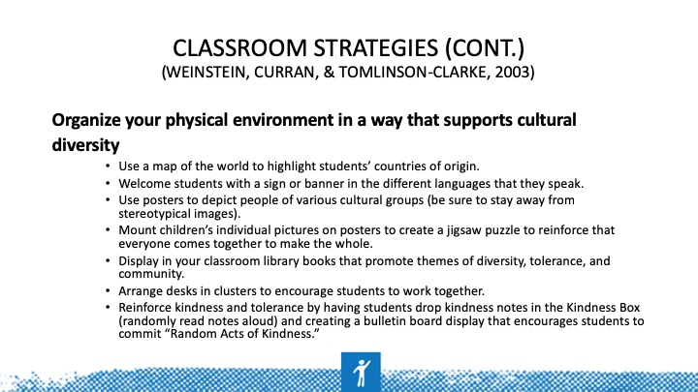 | Think about the ways in which you can strategically use the environment to communicate respect for diversity, reaffirm connectedness and community, and avoid marginalizing and disparaging students.
Slide 38 | 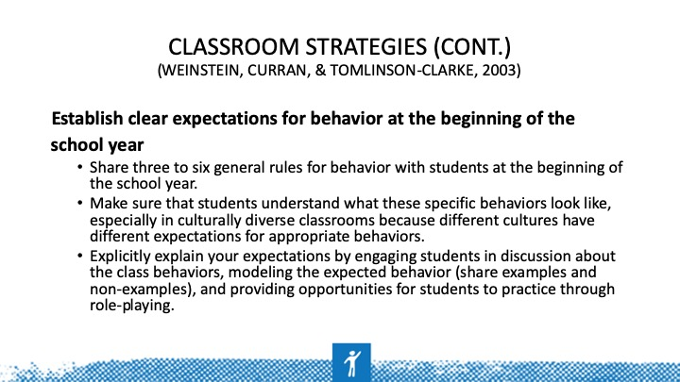 | Positively state your rules. Tell students what they need to do versus what they shouldn't do. Example: “Walk at all times” versus “Do not run.” Set the expectation and be explicit when you set it. Allow students to model for you how each rule looks to them. You can also share examples and non-examples with them.
Slide 39 | 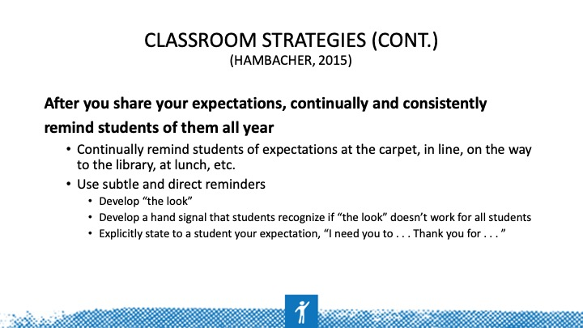
Slide 40 | 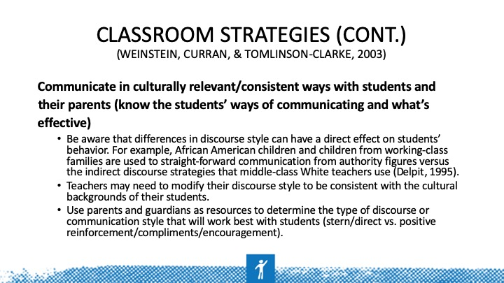
Slide 41 | 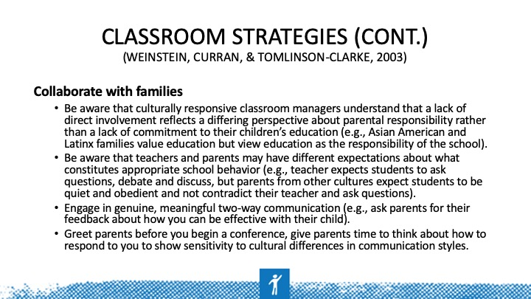
Slide 42 | 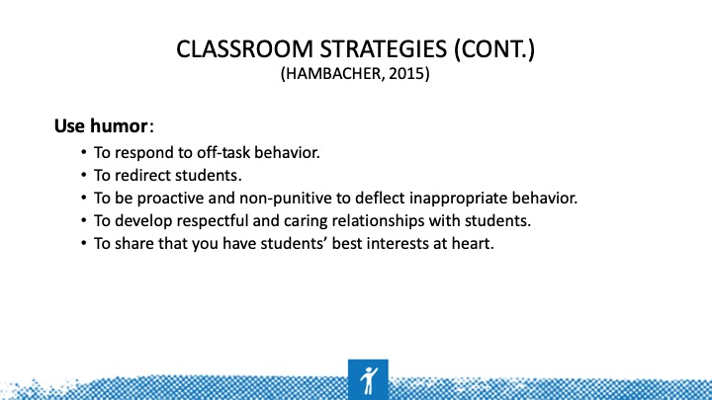
Slide 43 | 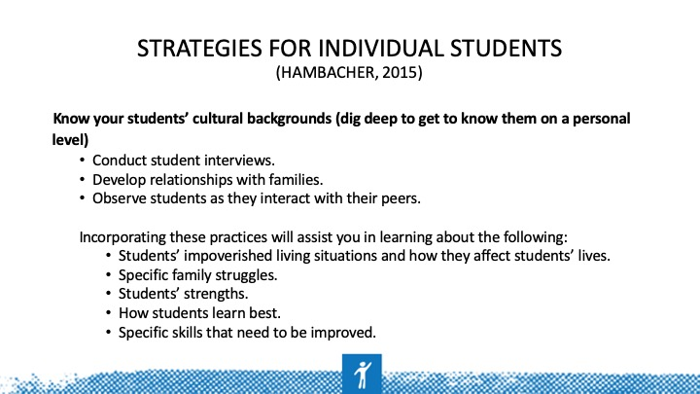 | You can also administer interest inventories or have parents complete them for younger students, which is an easy way to learn a lot about your students' interests in and out of school as well as their cultural experiences.
Slide 44 | 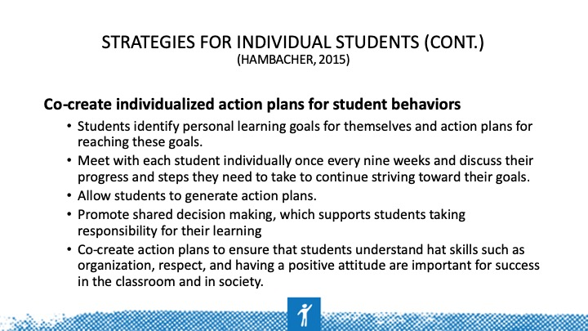
Slide 45 | 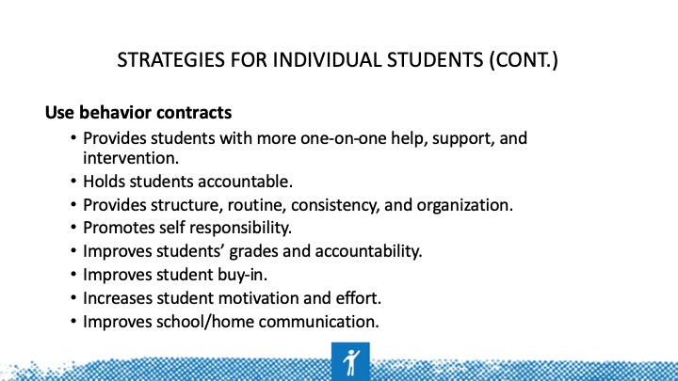 | pbisworld.com
Slide 46 | 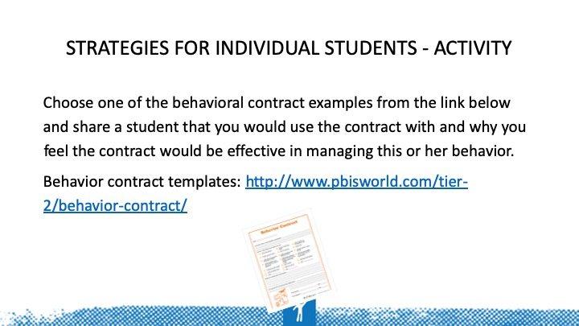 | Discuss with your group, and then share the different contracts they chose and why. Choose a spokesperson to share for your group.
Slide 47 | 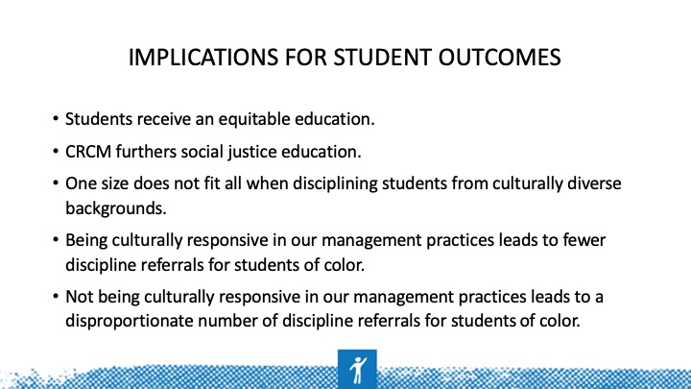 | What is social justice education? Teach your students about making positive change in the world by connecting with them, discussing real-world problems and multiple perspectives, creating classroom community, and including authentic assessment.
Slide 48 | 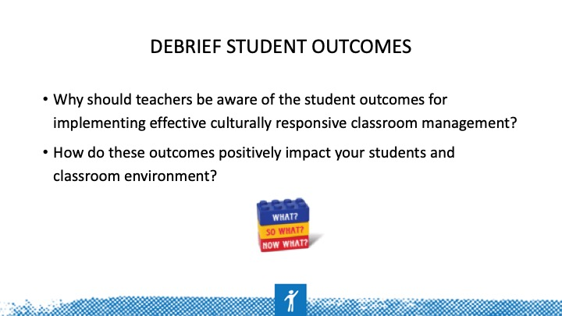
Slide 49 | 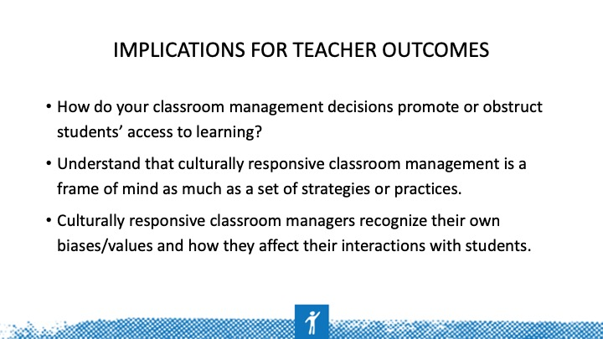
Slide 50 | 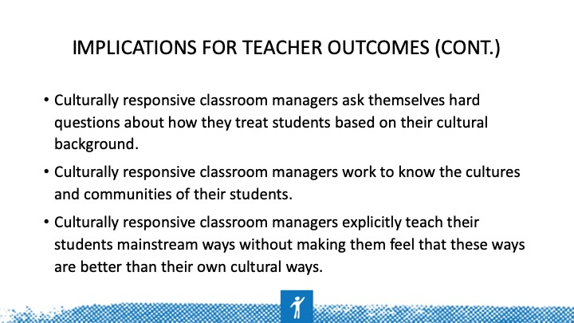
Slide 51 | 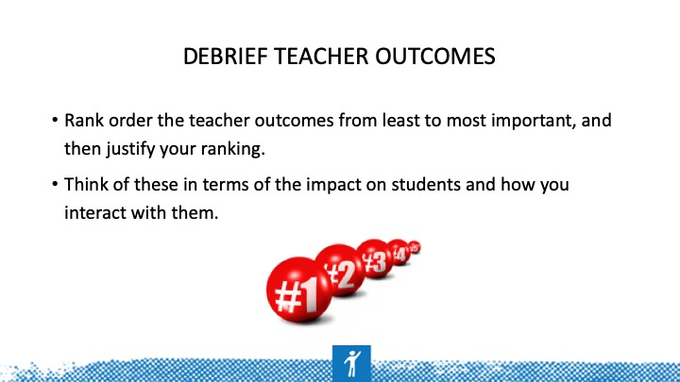
Slide 52

